

**DELHI NORTH DISTRICT ROAD SAFETY REPORT**



**Report by:**



**Data support by:**

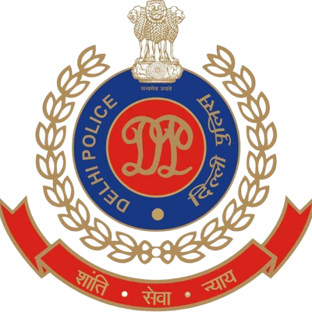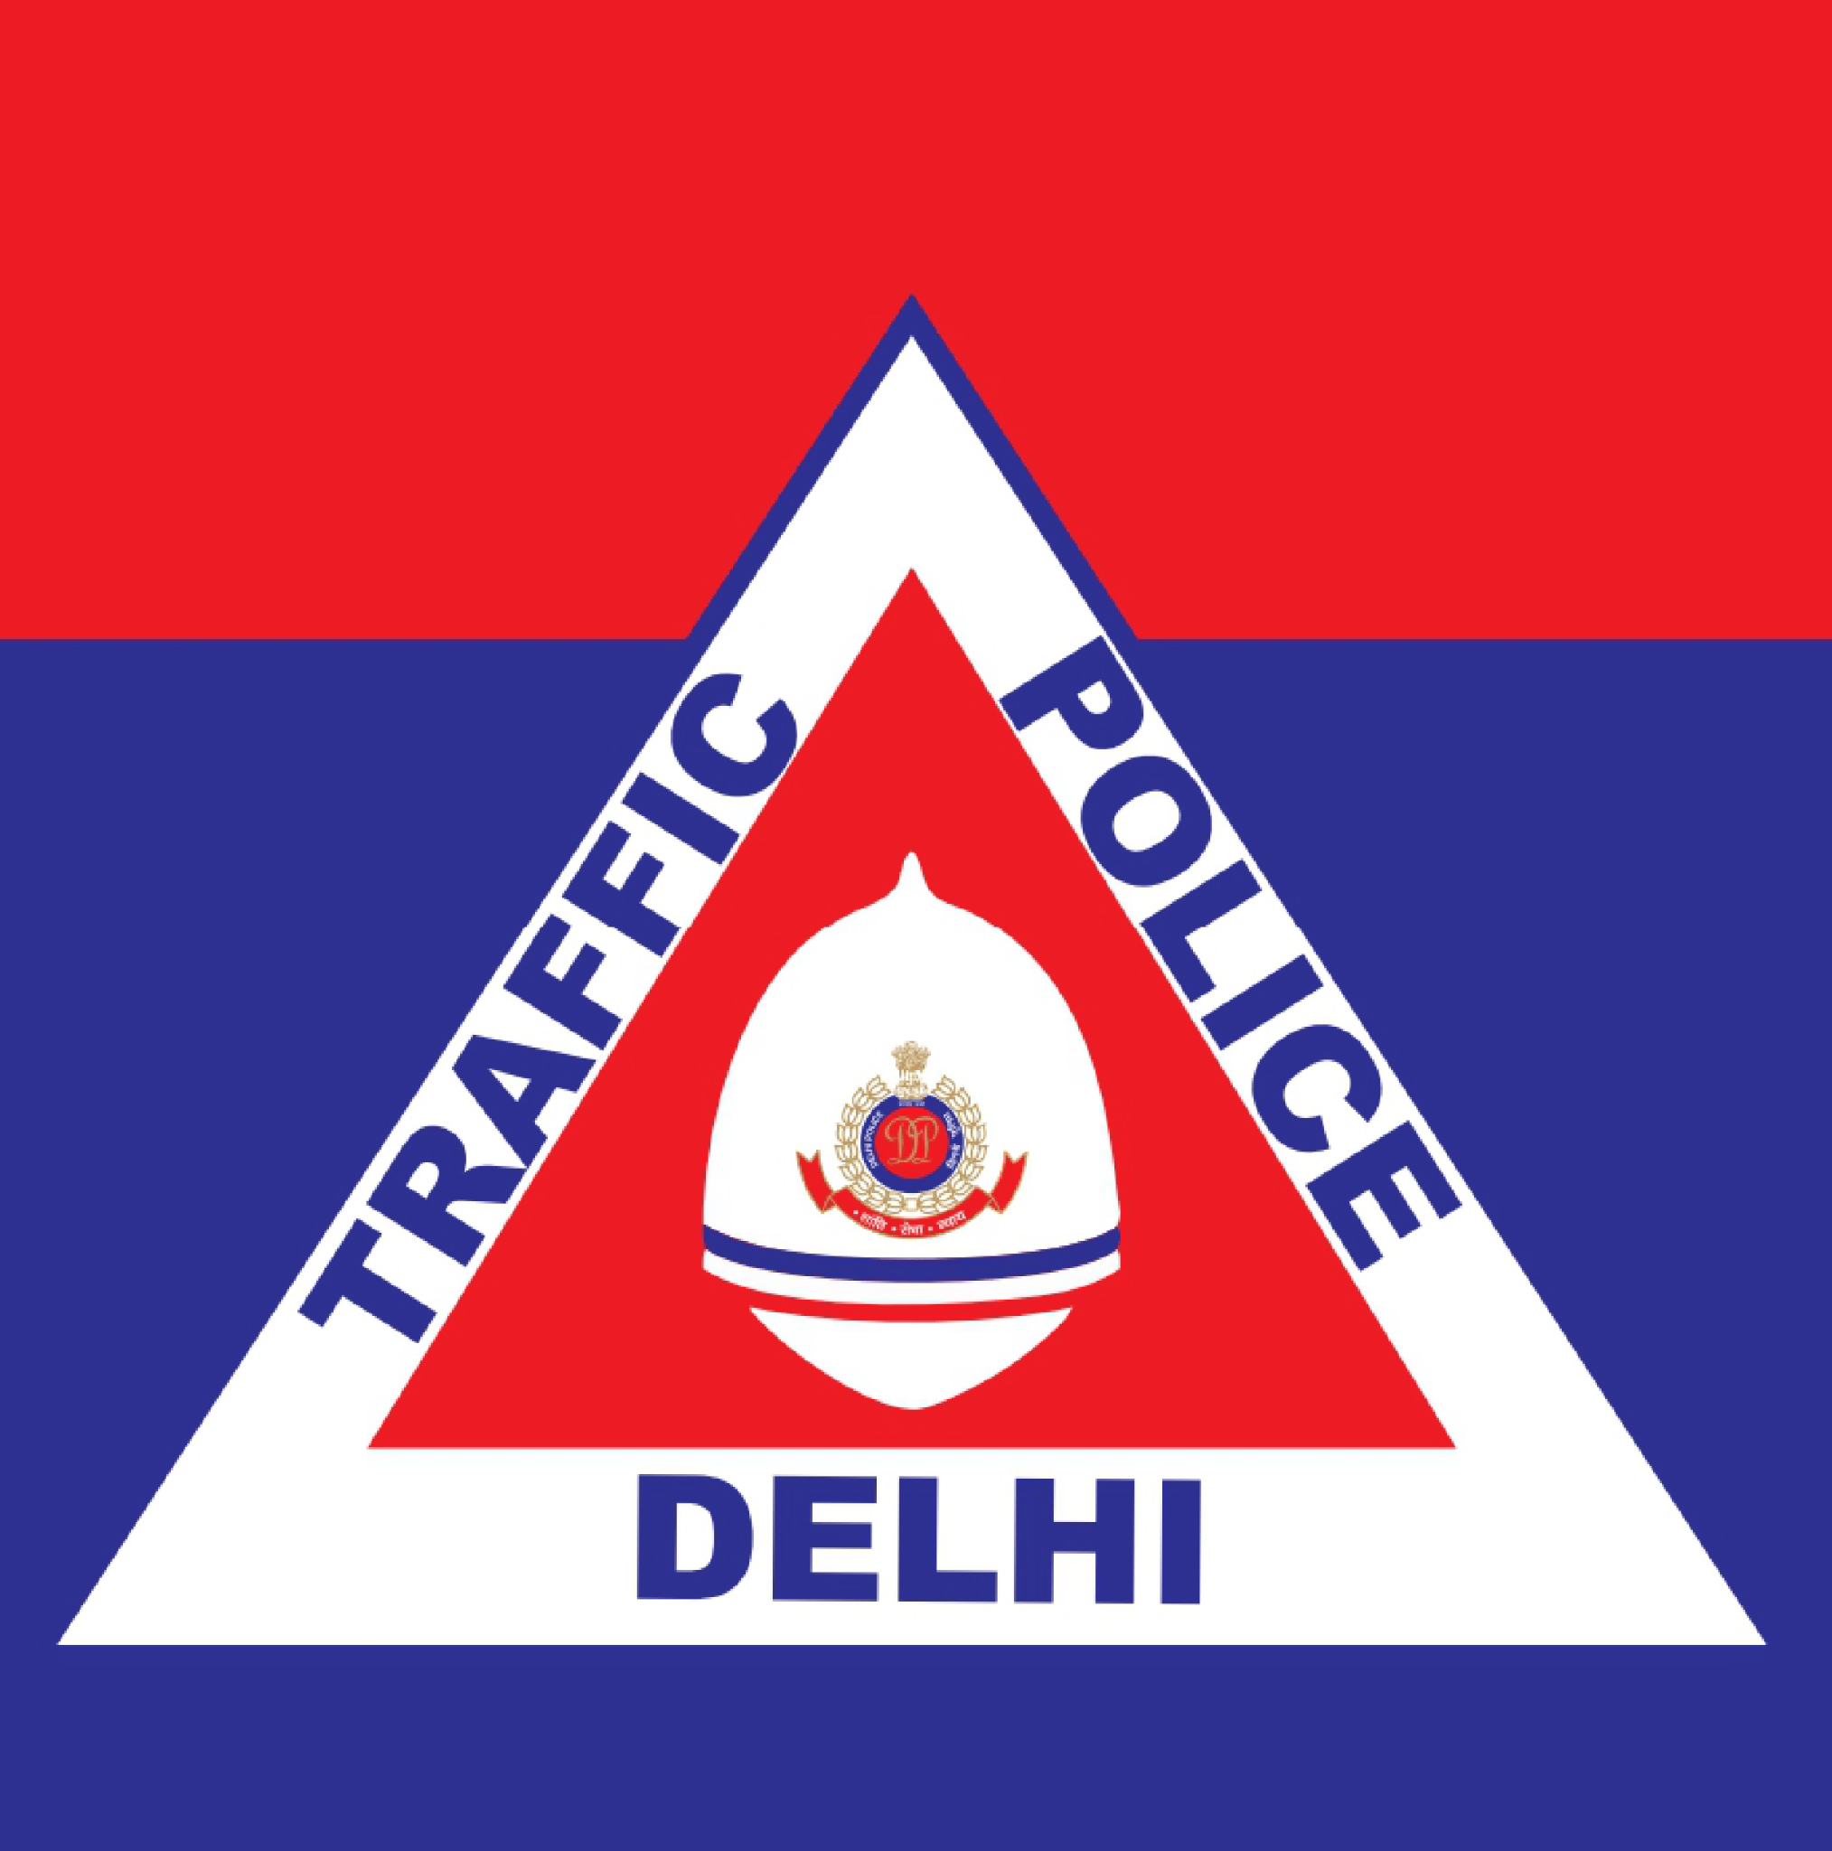

**Supported by:**







Contents

List of figures and tables 5

List of Abbreviations 6

Key Highlights 8

Introduction 9

Methodology 10

About the District 11

**a.** **Road Safety situation and trends in North district** 12

A.1 : Road crash death trends 12

A.1.1 : Fatal Road crashes 12

A.1.2 : Road crash fatalities by road user types 13

A.1.3 : Road crash deaths by months 14

A.1.4 : Road crash deaths by time and day of week 15

A.2 : Road crash deaths by age and gender (Age and Gender) 16

A.2.1 : Road crash deaths by gender 16

A.2.2 : Road crash deaths by age-groups and gender 16

A.3 : Road crash deaths by road user types (Road user types) 17

A.3.1 : Total road crash deaths by road user types (2019, 2021, 2022) 17

A.3.2 : Timewise road crash deaths by road user types 18

A.3.3 : Who-hit-whom matrix 19

A.4 : Hit-and-runs in fatal road crashes (Hit-and-runs) 20

A.4.1 : Percentage of hit-and-run and NON-HIT-AND-RUN cases. 20

A.4.2 : Hit-and-run road user types 20

A.5 : Road crash heatmaps (Heatmaps) 21

A.5.1 : Heatmap of all road crash deaths 21

A.5.2 : Heatmap of all pedestrian deaths in fatal road crashes 21

A.5.3 : Heatmap of all motorcycle (rider + pillion) related deaths 22

A.6 : High risk locations 23

A.6.1 : List of high-risk locations 23

A.6.2 : Map of all high-risk locations 23

A.6.3 : High risk corridors 24

**b.** **Data to Action** 25

B.1 : Mukarba Chowk 25

B.1.1 : General description of the site 25

B.1.2 : Existing scenario 25

B.1.3 : Issues identified 26

B.1.4 : Proposed design 27

B.2 : Azadpur Junction 30

B.2.1 : General description of the site: 30

B.2.2 : Existing land use 30

B.2.3 : Existing conflict points and Peak Hour traffic count 30

B.2.4 : Existing scenario 31

B.2.5 : Issues identified 31

B.2.6 : Proposed design 33

B.2.7 : Summary budget estimates 34

B.3 : Kingsway Camp 38

B.3.1 : General description of the site 38

B.3.2 : Existing land use 38

B.3.3 : Existing conflict points 38

B.3.4 : Existing scenario 39

B.3.5 : Issues identified 39

B.3.6 : Proposed design 41

B.3.7 : Summary budget estimates 42

B.4 : Safe School Zone: Sachdeva Public School, Rohini 46

B.4.1 : General description of the site 46

B.4.2 : Existing scenario 46

B.4.3 : Issues identified 47

B.4.4 : Activity map 48

B.4.5 : Proposed design 50

B.4.6 : Summary budget estimates 52

# List of figures and tables

Figure 1: Fatal crashes and road crash deaths 12

Figure 2: Road crash deaths by road user types 13

Figure 3: Average Road crash deaths over months 14

Figure 4: Road crash deaths by Gender 16

Figure 5: Road crash deaths by age groups and gender 16

Figure 6: Road crash deaths by road user types (2019, 2021 and 2022) 17

Figure 7: Road crash deaths by road user types for months 18

Figure 8: Percentage of hit-and-run and non-hit-and-run cases 20

Figure 9: Hit-and-run victims road user types 20

Figure 10: Heatmap of all road crash deaths in North district 21

Figure 11: Heatmap of all pedestrian deaths due to road crashes in North District 21

Figure 12: Heatmap of all motorcycle related deaths due to road crashes in North District 22

Figure 13: Map of all high-risk locations intervened in North District 23

Figure 14: Vulnerable Road crash deaths on corridors 24

Figure 15: Vulnerable Road crash deaths per km 24

Figure 16: Home to School travel modal distribution: SPS Rohini 47

Figure 17: School to home travel modal distribution 47

Table 1: Road crash deaths by time and day of the week 15

Table 2: Who-hit-who matrix 19

Table 3: List of high-risk locations 23

# List of Abbreviations

* **GNCTD** Government of National Capital Territory of Delhi
* **DM** District Magistrate
* **DMRC** Delhi Metro Rail Corporation
* **DRSC** District Road Safety Committee
* **DTC** Delhi Transport Corporation
* **DTP** Delhi Traffic Police
* **FIR** First Information Report
* **FOB** Foot Over Bridge
* **GIS** Geographic Information System
* **GT** Grand Trunk
* **HV** Heavy Vehicle
* **IACP** International Association of Chiefs of Police
* **IIT** Indian Institute of Technology
* **IPC** Indian Penal Code
* **IRC** Indian Road Congress
* **iRAD** Integrated Road Accident Database
* **ISBT** Inter State Bus Terminal
* **KM** Kilometre
* **LMV** Light Motor Vehicle
* **MACT** Motor Accident Claims Tribunal
* **MCD** Municipal Corporation of Delhi
* **MoRTH** Ministry of Road Transport and Highways
* **MPD** Master Plan for Delhi
* **MTW** Motorised Two-Wheeler
* **NCR** National Capital Region
* **NCT** National Capital Territory
* **NGO** Non-Governmental Organisation
* **NH** National Highway
* **NHAI** National Highways Authority of India
* **NIC** National Informatics Centre
* **NSP** Netaji Subhash Place
* **PCR** Police Control Room
* **QGIS** Quantum Geographic Information System
* **RSLA** Road Safety Lead Agency
* **SKV** Sarvodaya Kanya Vidyalaya
* **SOP** Standard Operating Procedure
* **TRIPC** Transportation Research and Injury Prevention Centre
* **UT** Union Territory
* **WHO** World Health Organisation

# Key Highlights

* The most vulnerable users in the north district are pedestrians and motorcyclists amounting to 44% and 39% respectively.
* The age group most at risk in the North district is those aged 20 to 29 years (24%), followed by individuals in the 30 to 39 years (21%) age range.
* Most of the fatal road crashes were hit and runs amounting to 69% of the total crashes; of these 52% crashes had pedestrians as the victims.
* Most of the fatal road crashes occurred between 10:00pm to 2:00am with a sudden spike on the weekends.
* Pedestrians and Motorcyclists were among the major victims of the fatal road crashes where they were hit primarily by cars and trucks.
* There are five high risk locations which have detailed recommendations on the infrastructure changes along with the summary budget estimates.

# Introduction

There has been an increase of road crash fatalities in Delhi since the easing of pandemic mobility restrictions. Vulnerable road users such as pedestrians, two-wheeler occupants and three-wheeler occupants are most at risk of severe injuries and - in worst case scenarios - death in a road crash. This risk which hinders the basic right of mobility for the road users warrants that effective and evidence-based road safety interventions and programs must be implemented regularly and systematically to mitigate the effects of road crashes.

In the year 2023, the Transport Department released the ‘Data to Action’ report which analysed 2019 to 2021 data and identified high-risk locations for each of the eleven districts in Delhi. The report provided detailed maps, overall analysis for the National Capital Territory (NCT) of Delhi, and general recommendations for each district. The report was presented to the District Road Safety Committees (DRSCs) to guide them in implementing road safety interventions and address the most urgent road safety risk factors in their jurisdictions. The DRSCs take the lead in drafting the district road safety plan. They are instrumental in planning road safety interventions for high-risk locations in the district, implement interventions on the ground, and disburse road safety funds.

As a next logical step, to take evidence-based action in order to reduce crashes, the Transport Department are producing highly customised district specific road safety reports (DRSR) for the DRSCs. These reports include detailed findings on road crashes in the given district including a list of high-risk locations and provide specific recommendations to reduce crashes. The purpose of these DRSR is to guide DRSCs in implementing evidence-based interventions to reduce crash fatalities in high-risk locations and provide detailed infrastructure designs for specific locations which can be readily implemented on ground. The ultimate goal of this process is to inform and train the DRSC members in replicating the evidence-based action in the future.

# Methodology

*Data Source*

The District Road Safety Report (DRSRs) focused on road crash fatalities’ data in the National Capital Territory (NCT) of Delhi from the years 2019, 2021 and 2022. The data source for this report is police road crash data records from the Motor Accident Claims Tribunal (MACT) cells of the districts. In addition, this data is supplemented by the FIR lists from the Delhi Traffic Police. The dataset was compiled, digitised, and cleaned at the Transport Department.

Data Analysis

The digitised datasets were compiled and analysed using MS Access to produce descriptive statistics and were mapped using Quantum Geographic Information Systems (QGIS) platform, to identify high-risk locations including high-risk corridors in each district. Similar process will be followed for producing district road safety reports for the remaining districts.

On-site Investigation of High-risk Locations and Corridors

An in-depth and on-site investigation was conducted for the identified high-risk locations. At the site, both qualitative and quantitative data were collected which informed the design of the interventions. The data collection was based on the following parameters:

* Inspection of the road infrastructure and land use at the site.
* Identification of hazards and conflict points, especially pedestrians’ movement, bus stop locations.
* Assessment of the type and quality of enforcement
* Observations on road user behaviour, parked vehicles, street vendors and accessibility of vulnerable road users
* Identification of types of road users and traffic mix and speed.

These data points were collated and presented for the selected high-risk sites, and were used to inform the design of the proposed interventions.

Report Structure

Each district has a dedicated report. There will be a total of 11 reports - one for each district in NCT Delhi. The report is divided into three parts. The first part includes the introduction of road safety in the context of the district, and methodology that was followed to produce the report. The second part covers the discussion on the road safety situation in the given district. Finally, the last part of the report provides detailed investigation and recommendations for the selected high-risk sites in the district.

# About the District

North Delhi is an administrative district of the National Capital Territory of Delhi in India. Alipur is the administrative headquarters of this district. North Delhi is bounded by the Yamuna River and the district of Central Delhi on the east and by the district of North West Delhi to the west. Administratively, the district is divided into three subdivisions, Model Town, Narela, and Alipur.

Area: 291.66 sq km

Municipality: 1

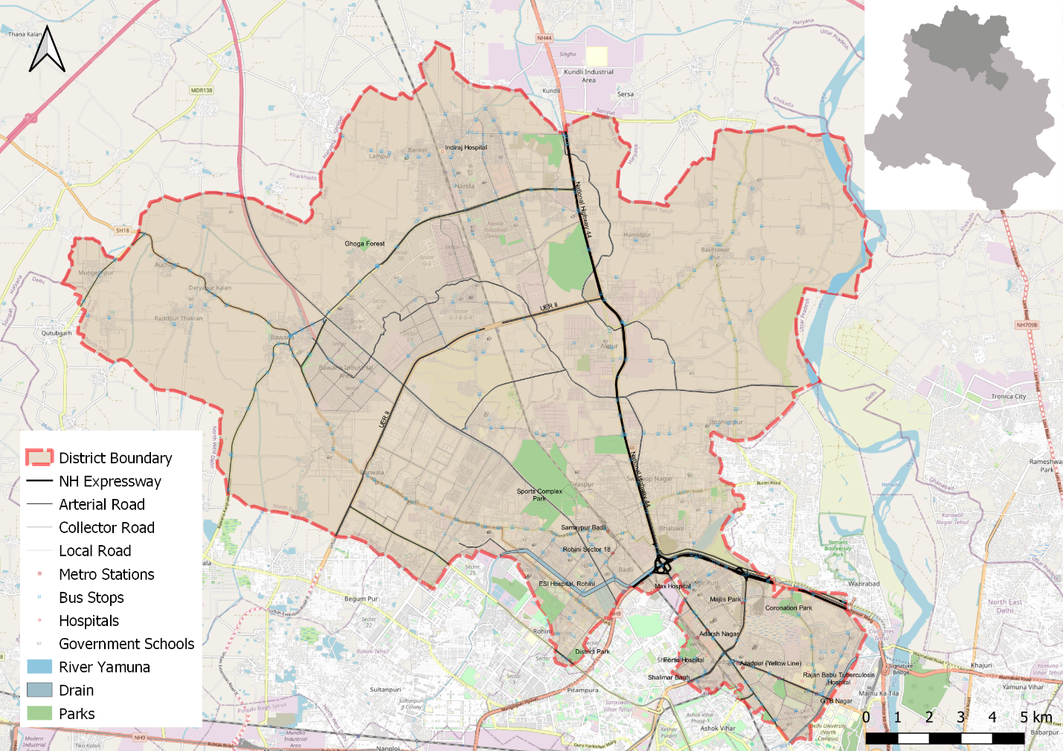

# **Road Safety situation and trends in North district**

## : Road crash death trends

### : Fatal Road crashes

Figure 1: Fatal crashes and road crash deaths

There were 262 fatal road crashes in the North District of Delhi in 2022 with 267 persons killed in these crashes. There is a 36% increase compared to the previous year 2021 which is 196. One person is killed in road crashes in the North District every one to two days.

### : Road crash fatalities by road user types

Figure 2: Road crash deaths by road user types

Motorcyclists, auto rickshaw occupants and pedestrians formed a majority of persons killed in road crashes in the North District across all three years. Between the highlighted categories, the motorcyclist and autorickshaw occupants’ fatalities surpassed the pedestrian fatalities in 2021 and 2022.

### : Road crash deaths by months

Figure 3: Average Road crash deaths over months

January, March and August witnessed the highest number of persons killed followed by April and October, there is no discernible pattern of fatalities by month.

### : Road crash deaths by time and day of week

|  |  |  |  |  |  |  |  |  |
| --- | --- | --- | --- | --- | --- | --- | --- | --- |
|  | **Monday** | **Tuesday** | **Wednesday** | **Thursday** | **Friday** | **Saturday** | **Sunday** | **Total** |
| **02:00-06:00** | 8 | 10 | 7 | 8 | 6 | 6 | 6 | 51 |
| **06:00-10:00** | 20 | 7 | 15 | 9 | 10 | 9 | 10 | 80 |
| **10:00-14:00** | 13 | 9 | 7 | 9 | 9 | 16 | 11 | 74 |
| **14:00-18:00** | 14 | 13 | 19 | 14 | 17 | 17 | 14 | 108 |
| **18:00-22:00** | 22 | 17 | 15 | 19 | 33 | 16 | 25 | 147 |
| **22:00-02:00** | 25 | 23 | 24 | 27 | 24 | 36 | 40 | 199 |
| **Total** | 102 | 79 | 87 | 86 | 99 | 100 | 106 | 659 |

Table 1: Road crash deaths by time and day of the week

Note: Data not available for three road crash deaths

Thirty percent of the total road crash deaths occurred at night 10:00 pm to 2:00 pm. Similarly, 38% of the total deaths occurred either on Saturdays or on Sundays.

## : Road crash deaths by age and gender (Age and Gender)

### : Road crash deaths by gender

Figure 4: Road crash deaths by Gender

### : Road crash deaths by age-groups and gender

Figure 5: Road crash deaths by age groups and gender

Looking at the absolute numbers, the males had a higher number of fatalities 89% compared to females. Among the males, the fatalities were observed to be highest in the age group of 20-29 years, followed by 30-39 years.

## : Road crash deaths by road user types (Road user types)

### : Total road crash deaths by road user types (2019, 2021, 2022)

**Total fatalities:662**

Figure 6: Road crash deaths by road user types (2019, 2021 and 2022)

*Other includes cycle rickshaws, converted rickshaws and hand carts

Ninety percent of fatalities were among vulnerable road users (i.e., pedestrians, motorcyclists, cyclists, and auto rickshaw occupants). Among this, forty four percent of road crash deaths in the North district were among pedestrians, followed by motorcyclists (39%).

### : Timewise road crash deaths by road user types

Figure 7: Road crash deaths by road user types for months

### : Who-hit-whom matrix

|  |  |  |  |  |  |  |  |  |  |
| --- | --- | --- | --- | --- | --- | --- | --- | --- | --- |
| **Victim Road User** | **Impacting Vehicle** | | | | | | | | |
| **Motorcycle** | **3-Wheeler** | **Car** | **Bus** | **Truck/Tractor** | **Single Vehicle Crash** | **Other** | **Unknown** | **Total** |
| **Pedestrian** | 12 | 3 | 34 | 6 | 66 | 0 | 4 | 167 | 292 |
| **Cyclist** | 3 | 0 | 5 | 0 | 6 | 0 | 0 | 2 | 16 |
| **Motorcyclist** | 9 | 3 | 27 | 8 | 81 | 19 | 2 | 113 | 262 |
| **3-Wheeler Occupant** | 1 | 0 | 7 | 0 | 4 | 4 | 1 | 11 | 28 |
| **Car Occupant** | 0 | 0 | 5 | 4 | 12 | 4 | 2 | 4 | 31 |
| **Truck/Tractor Occupant** | 2 | 0 | 1 | 2 | 10 | 4 | 3 | 5 | 27 |
| **Other** | 2 | 0 | 1 | 0 | 0 | 2 | 0 | 1 | 6 |
| **Total** | 29 | 6 | 80 | 20 | 179 | 33 | 12 | 303 | 662 |

Table 2: Who-hit-who matrix

Note: Other includes cycle rickshaws, converted rickshaws and hand carts

Among all fatal road crashes where the impacting vehicle was known, pedestrians and motorcyclists were found to be the most vulnerable category of road users. They were often hit by trucks and tractors. Hit-and-run crashes dominate both the categories of cases where the impacting vehicle was not known for 167 cases in case of pedestrians and 113 in case of motorcyclists.

## : Hit-and-runs in fatal road crashes (Hit-and-runs)

### : Percentage of hit-and-run and NON-HIT-AND-RUN cases.

Figure 8: Percentage of hit-and-run and non-hit-and-run cases

Overall, Three out of five crashes are hit-and-run cases. The high rate of hit-and-run cases is indicative of non-reporting of accused vehicles as well as non-reporting of crashes by the public.

### : Hit-and-run road user types

Figure 9: Hit-and-run victims road user types

## : Road crash heatmaps (Heatmaps)

### : Heatmap of all road crash deaths

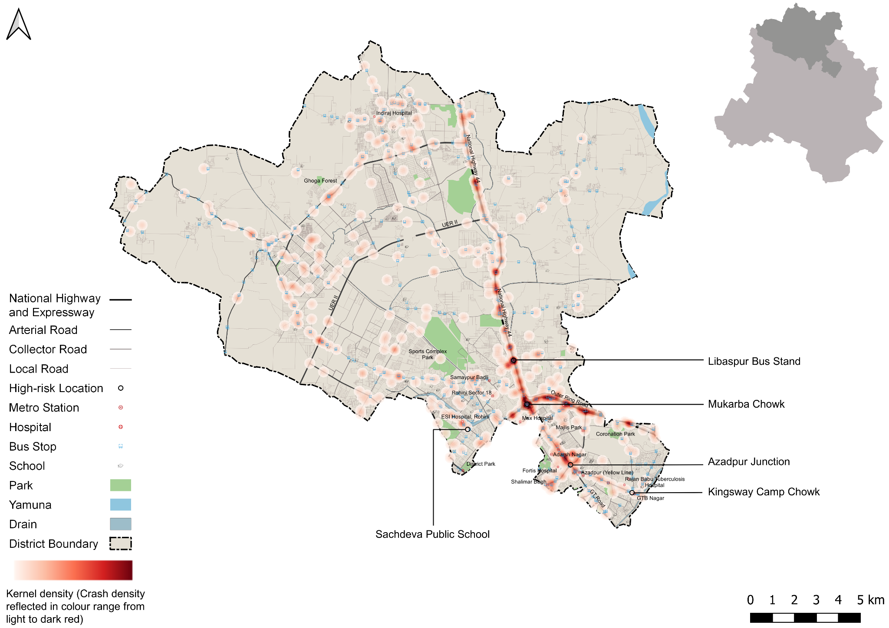

Figure 10: Heatmap of all road crash deaths in North district

### : Heatmap of all pedestrian deaths in fatal road crashes

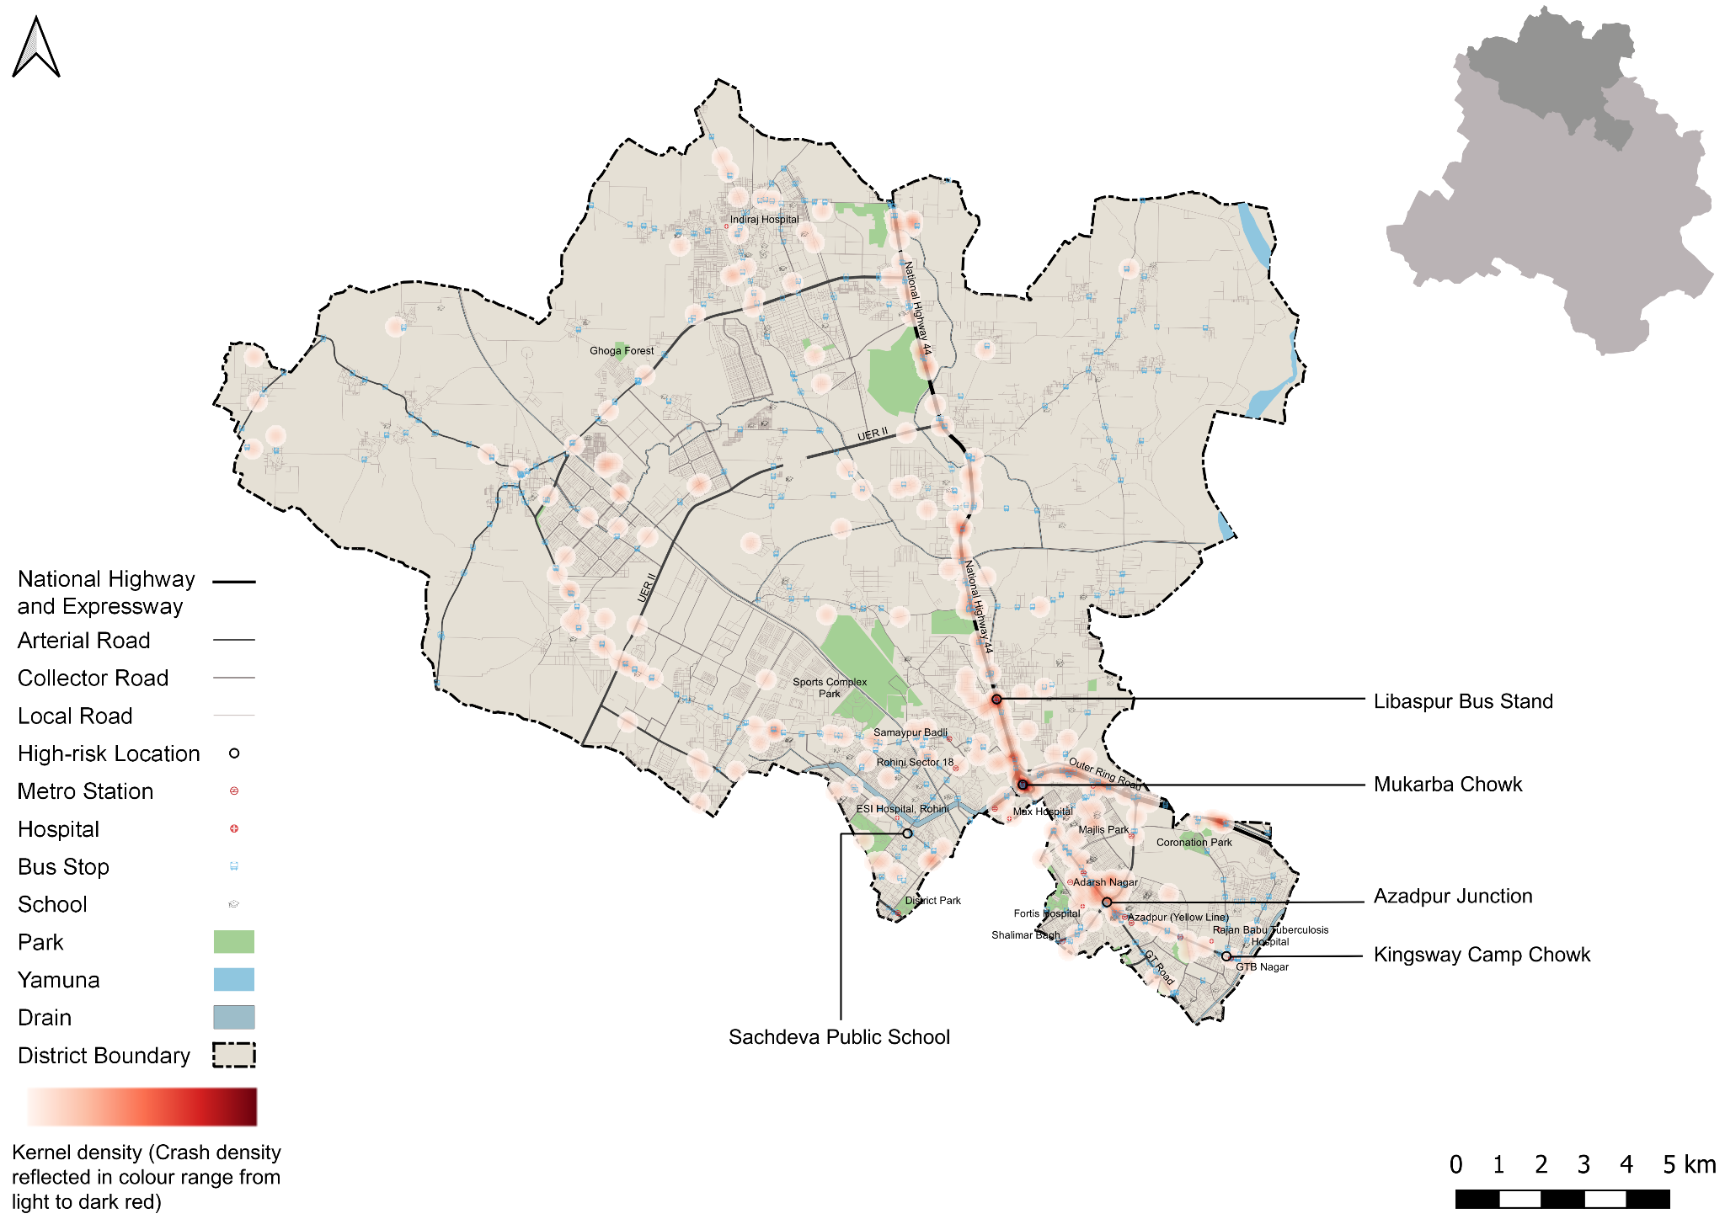

Figure 11: Heatmap of all pedestrian deaths due to road crashes in North District

### : Heatmap of all motorcycle (rider + pillion) related deaths

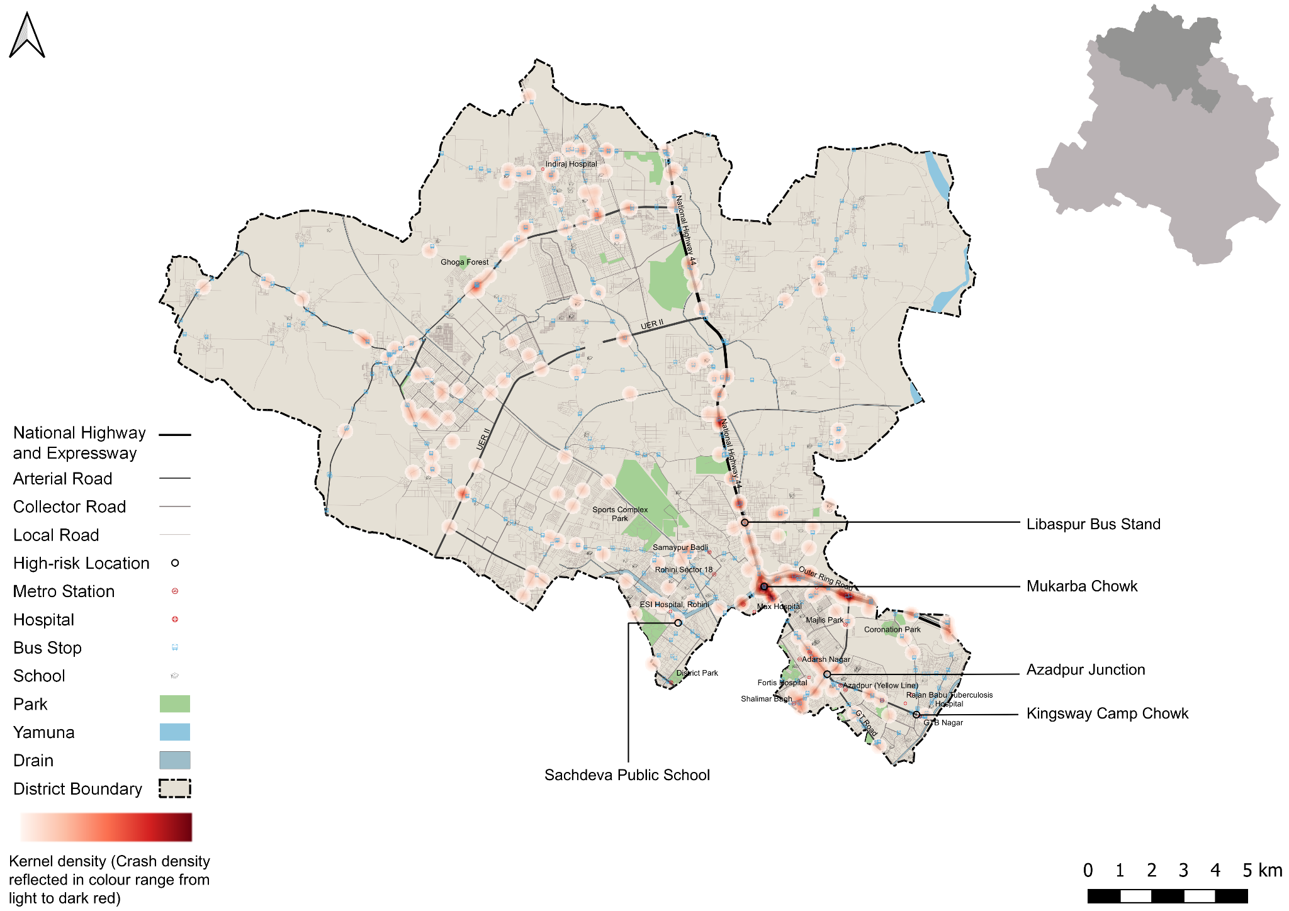

Figure 12: Heatmap of all motorcycle related deaths due to road crashes in North District

## : High risk locations

### : List of high-risk locations

The following is a list of high-risk locations in the North district which includes the number of fatal crashes, hit-and-run crashes, and deaths occurred during these crashes in years 2019, 2021 and 2022. Mukarba Chowk has the highest number of fatal incidents and fatalities out of all the identified locations. This is followed by Azadpur Junction and Libaspur Bus Stand.

|  |  |  |  |
| --- | --- | --- | --- |
| **High Risk Location** | **Total fatal crashes** | **Total hit and run fatal crashes** | **Total persons killed** |
| Mukarba Chowk | 36 | 29 | 36 |
| Azadpur Junction | 13 | 8 | 13 |
| Libaspur Bus Stand | 9 | 7 | 10 |
| Kingsway Camp Chowk | 1 | 1 | 1 |
| Sachdeva Public School | 1 | 1 | 1 |

Table 3: List of high-risk locations

### : Map of all high-risk locations

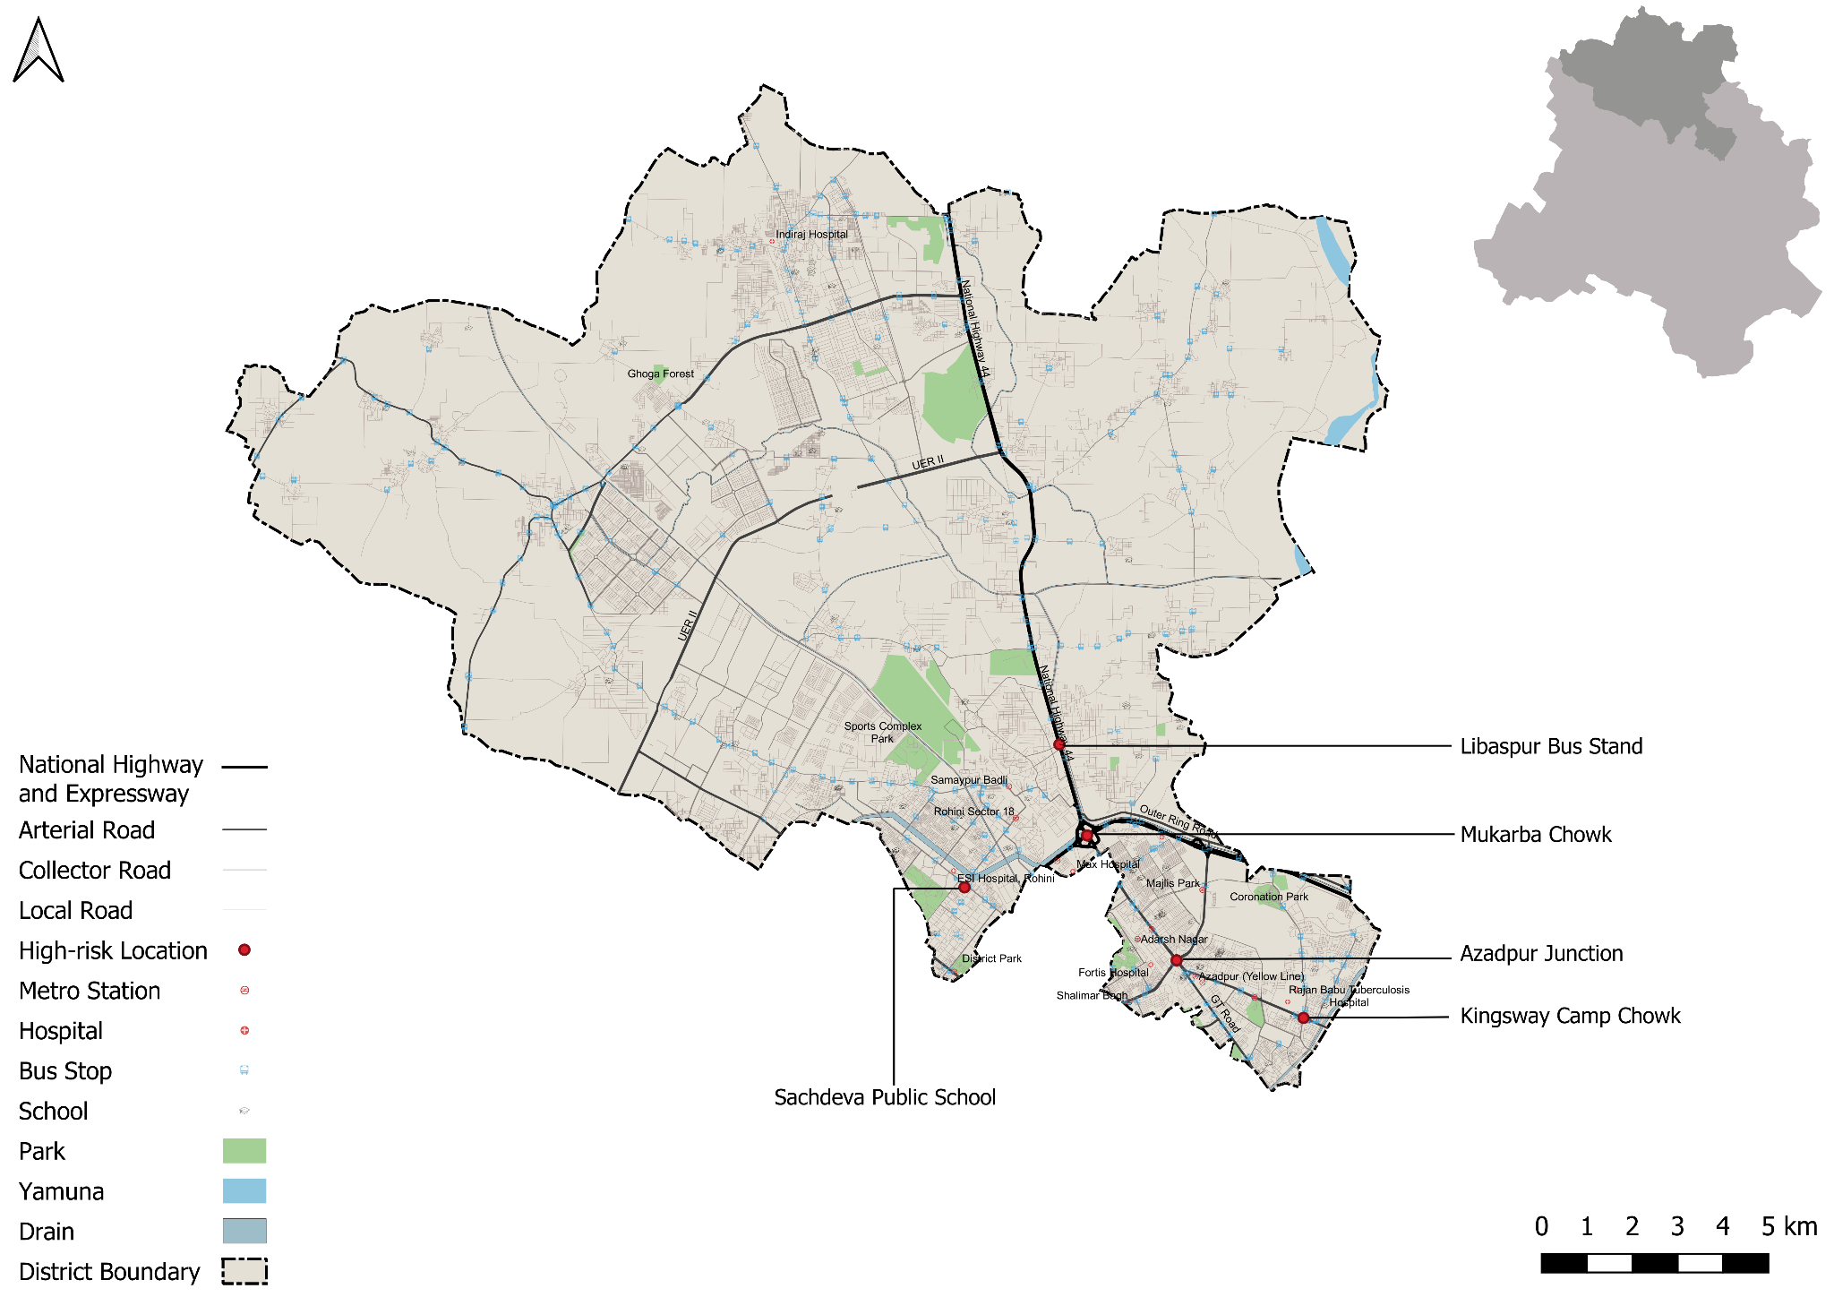

Figure 13: Map of all high-risk locations intervened in North District

### : High risk corridors

Figure 14: Vulnerable Road crash deaths on corridors

Figure 15: Vulnerable Road crash deaths per km

# **Data to Action**

## : Mukarba Chowk

### : General description of the site

Mukarba chowk (Latitude 28°44'05.6"N Longitude 77°09'20.9"E) has been a blackspot for the last three years. It intersects the Grand Trunk Road and the outer ring road. It is served by the yellow line, the nearest metro stations being Haiderpur Badli Mor and Jahangirpuri. The Mukarba Chowk intersection is a very large-scale high speed vehicular infrastructure with an area of 3,00,000 Sq.m, making it challenging for other street users to navigate their desired routes through it. This busy intersection with multiple lanes and levels including cloverleafs is a meeting point for major arterial roads. However, it is part of a huge urban area surrounded by residential & industrial neighbourhoods such as Sanjay Gandhi Transport Nagar, Bhalswa Jahangir Nagar, Jahangirpuri industrial area, Baldi village & Bhalswa landfill site as activity generators. Apart from the neighbouring context Intersection also acts as a major grade separated interchange for public transport. This makes it a hub of pedestrian movements accessing various nodes around it & connected to the rest of the city through public transport located at the centre of the intersection.

### : Existing scenario

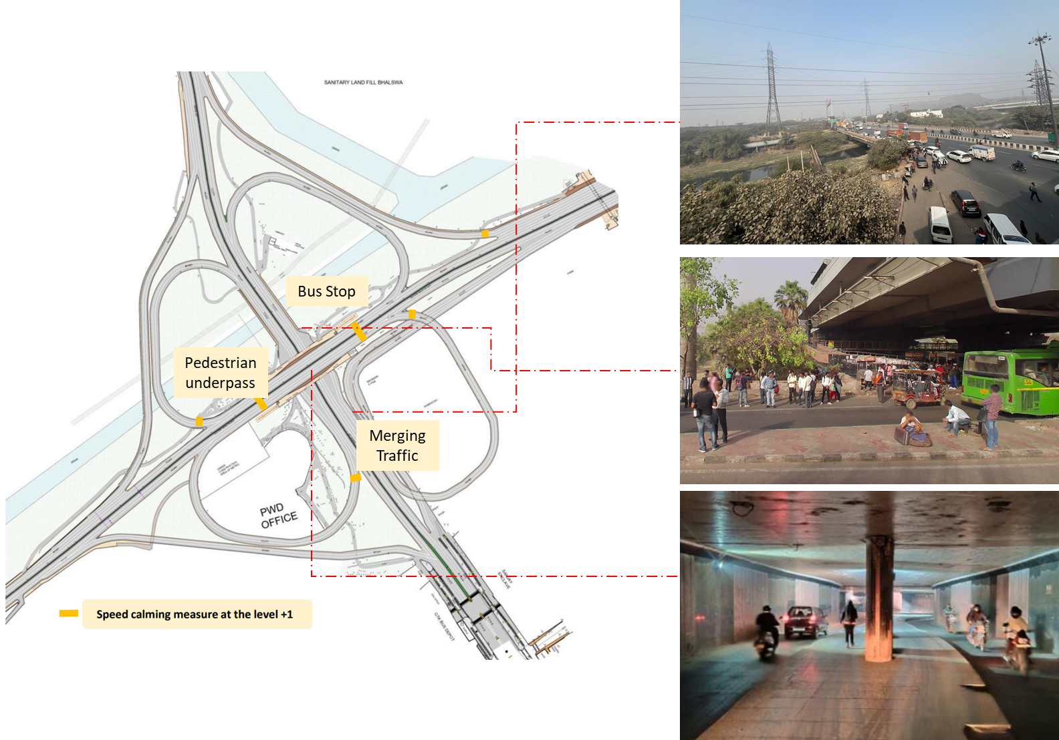

### : Issues identified

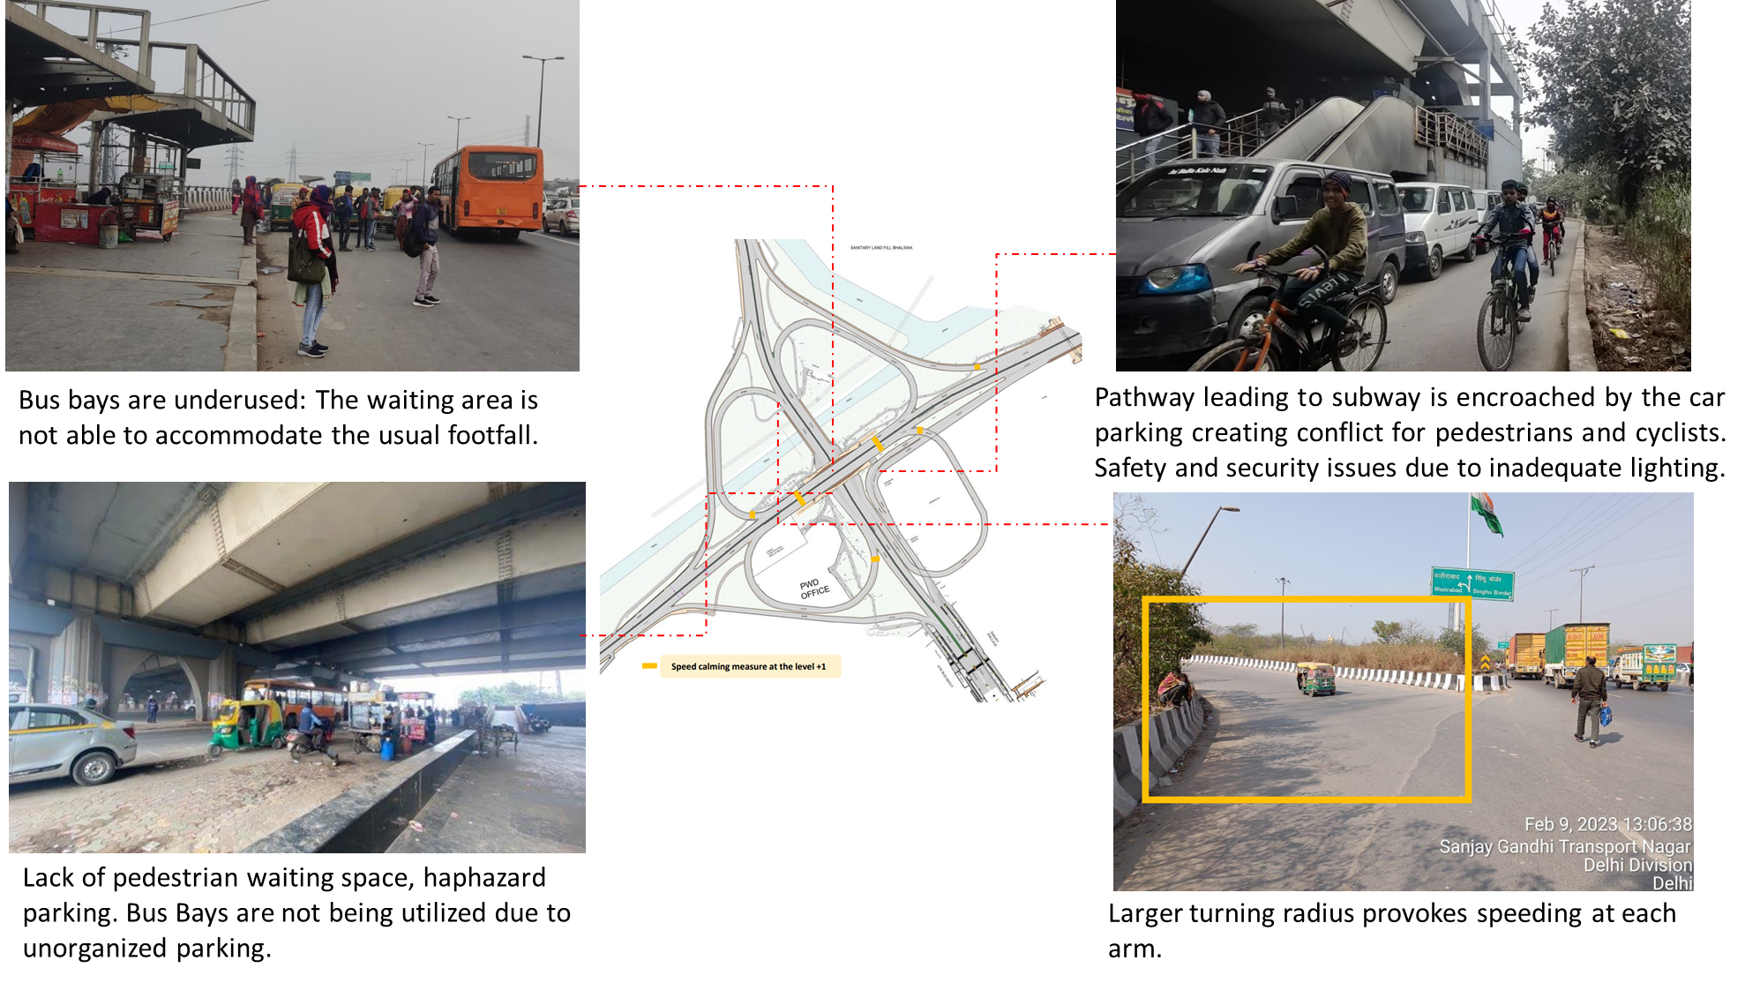

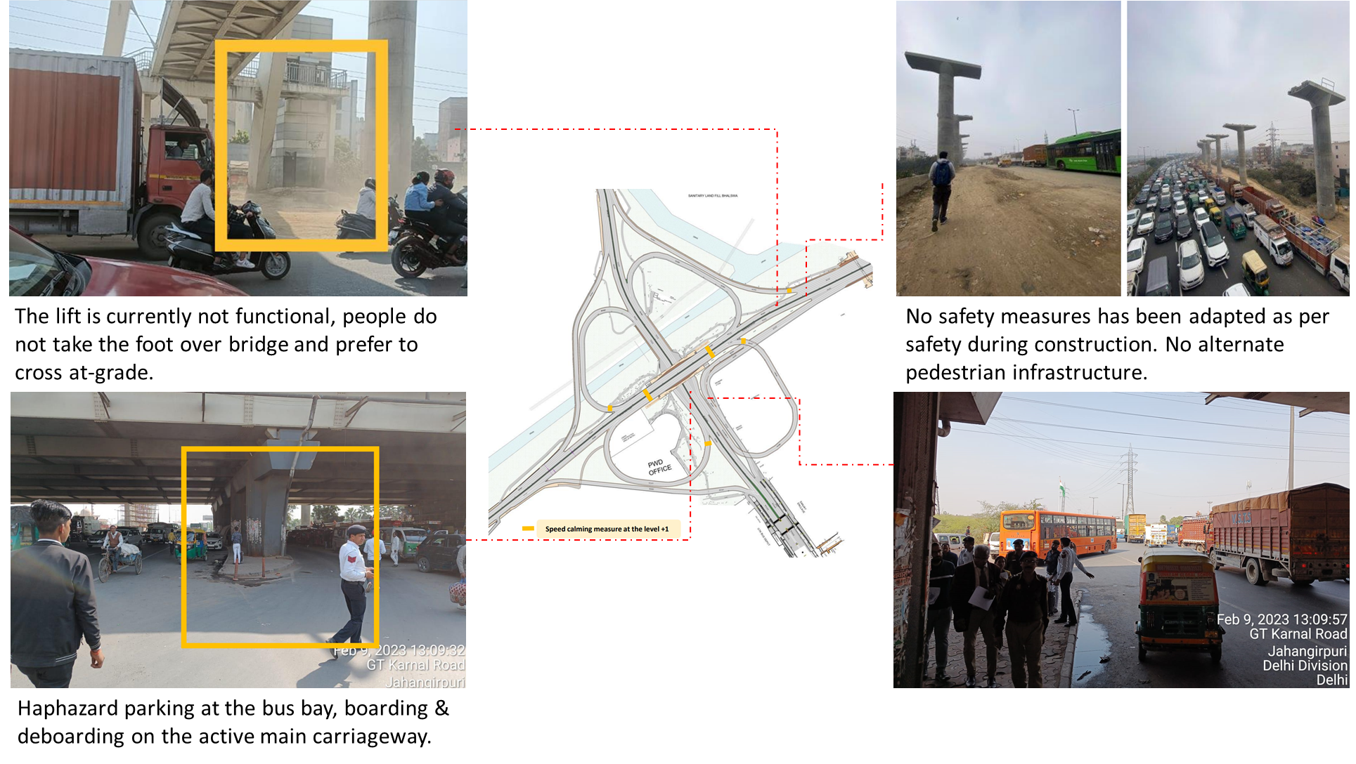

1. The bus bays on the flyover are not wide enough to accommodate the footfall.
2. No safety measures have been adapted as per safety during construction such as an alternate pedestrian path during the construction time.
3. Lack of pedestrian waiting space for buses. Haphazard on-street parking stopping to pick up passengers and underutilised bus stops leads to further congestion.
4. Pathway Leading to subway is encroached by the car parking creating conflict for pedestrian & cyclist, safety & security Issue due to inadequate Lighting.
5. The lifts at the foot over bridges were not functional, people prefer to cross at grade then take the stairs of the foot over bridges.
6. People are dropped off under the flyover and they walk upto the nearby villages/ bus stops that do not have a continuous pedestrian path.
7. Haphazard parking at the bus bay, boarding & deboarding happening on the main carriageway.
8. Larger turning radius encourages speeding at entry/exit points of the arms of the intersection.

### : Proposed design

The infrastructure has been designed in purview to accommodate vehicular demands, without incorporating human-scale components. Hence, it is suggested to develop a comprehensive public space beneath this intersection at the ground level, which is vibrant with multiple activities, supported by adequate lighting & directional signage.

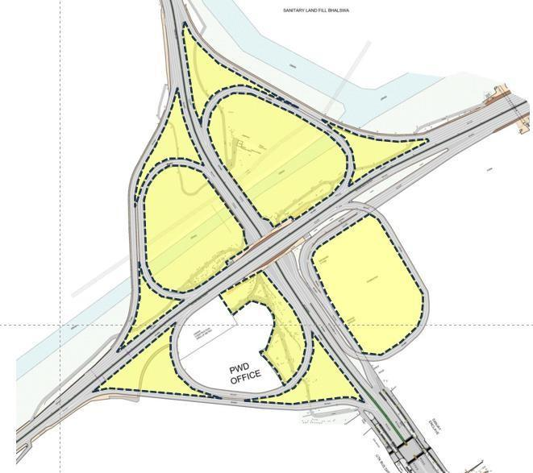

* A comprehensive public space design needs to be developed for approx. 92,000 Sq.m at the ground level, completely segregated from the current vehicular infrastructure.
* In addition to public space intervention, there is a need to improve vehicle infrastructure for the safety of all road users.
* Improvement of the existing infrastructure on three levels at the centre of the intersection is crucial as it is a public transport interchange hub, due to the presence of bus stops & IPT systems for last-mile connectivity at multiple levels. Pedestrians commuting to reach their destinations frequently board and alight from buses and IPT at these levels, raising multiple conflicts with vehicular movements.
* To address these pressing issues the road crashes at Mukarba Chowk should be investigated on the spot for better understanding of causes and remedial measures.
* Meanwhile, at the existing infrastructure, WRI India has suggested six key measures, i.e Geometrical correction, Signage, Speed calming measures, Lighting, CCTV surveillance & road marking to improve the safety & security of the intersection at three levels as marked on the conceptual drawings submitted to PWD & Transport department.

The above-mentioned recommendations have been identified on the conceptual plans below for all the three levels.

Suggested measures at flyover level Suggested measures at ground level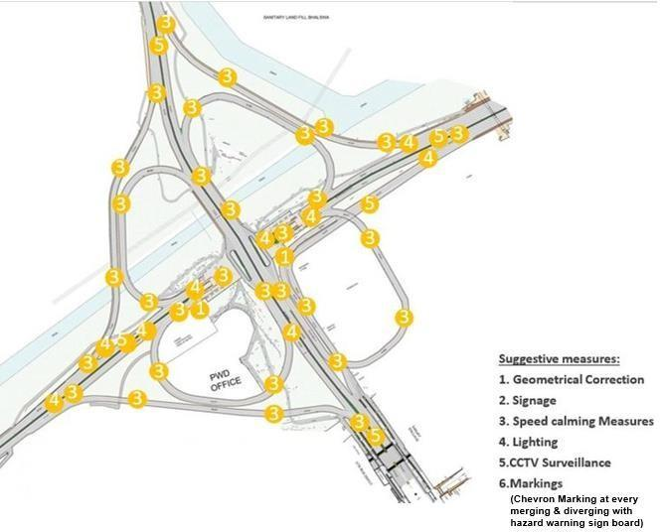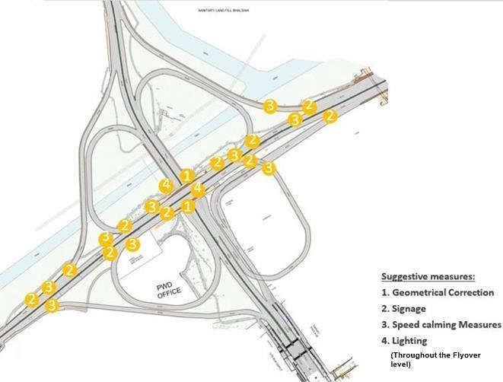

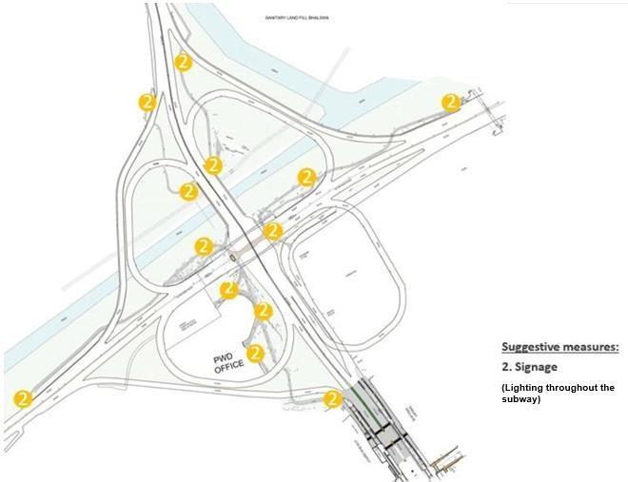

Suggested measures at subway level.

1. More bus shelters needed to cater the footfall.
2. Infrastructure for NMV and pedestrians should be designed below the metro line (to connect the village and the foot over bridge). DMRC to provide measures for traffic management in work zones as per IRC-SP-55 for overall safety for the proposed metro line.
3. Footpath improvement, and kerb/ edge repair works need to be done streamlining autos, buses and private vehicle movement and parking. Providing table-top crossings for speed calming and pedestrians.
4. Pathways leading to subway level need to be regulated; safety and lighting needs to be worked out; parking should be restricted for uninterrupted paths for cyclists.
5. Lift not functional, regular maintenance to be done along with maintenance of access ramp to maximise the usage of the foot over bridge.
6. Increase the legibility & Safety & security of the walking & cycling infrastructure by providing adequate lighting, increase the visibility by cleaning the vegetation along the island.
7. Core area demarcation missing: Flexible bollards, Hazard markers, Solar road studs are required.
8. Speed calming measures, Such as speed tables, need to be provided for reducing the speed. Clear the vegetation near the island to maximise the visibility.
9. Height restriction by using gantry for heavy vehicles. Lighting/Safety/Signages. Speed calming measures clear the vegetation to maximise the visibility.

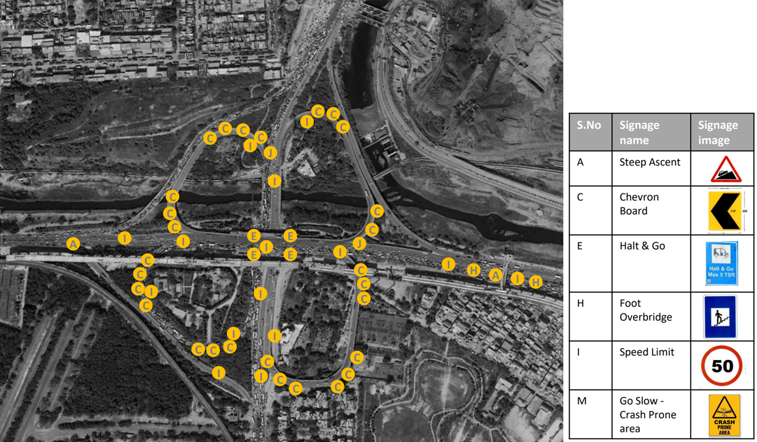

## : Azadpur Junction

### : General description of the site:

Azadpur Junction (Latitude 28° 42 '36.33"N; Longitude 77° 10' 33.96"E) is a signalised four-arm intersection. It acts as a major point for passengers coming from the north Delhi to west and central Delhi side. There is a high number of pedestrian footfall due to commercial activities near junctions. This area is served by the red and yellow metro lines, and the nearest metro stations are Azadpur metro station and Adarsh Nagar metro station. Proposed magenta metro line is under construction by Delhi Metro Rail Corporation. The intersecting roads are Grand Trunk Road and Mahatma Gandhi Road.

### : Existing land use

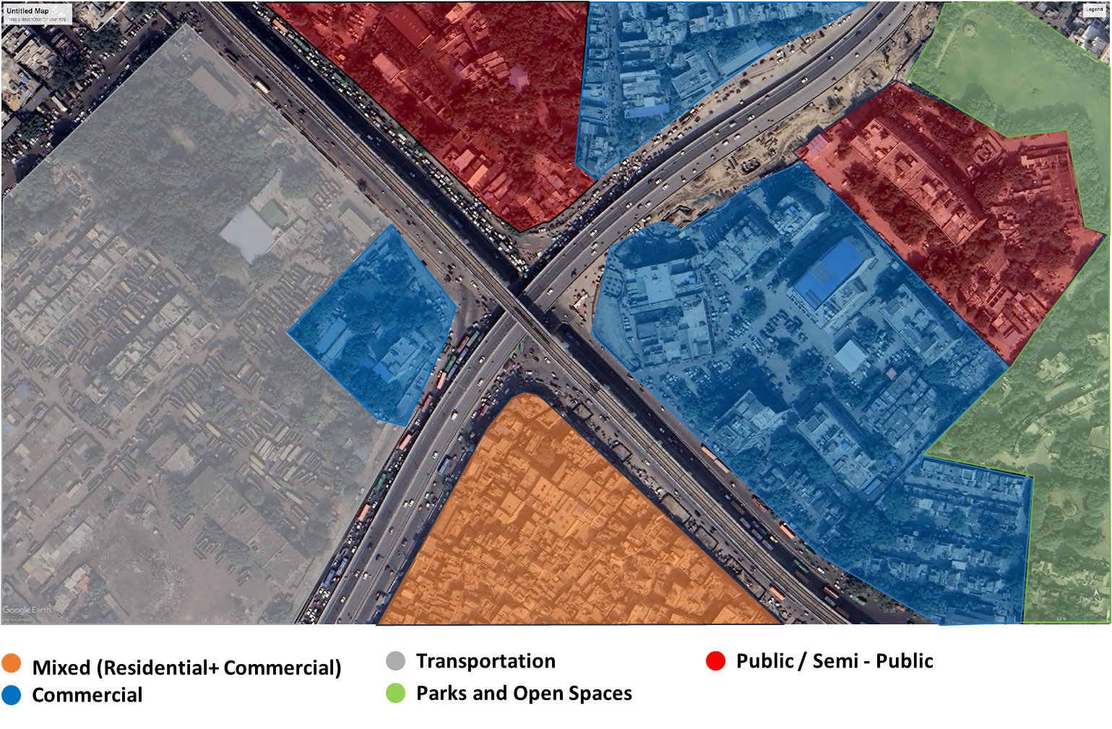

### : Existing conflict points and Peak Hour traffic count

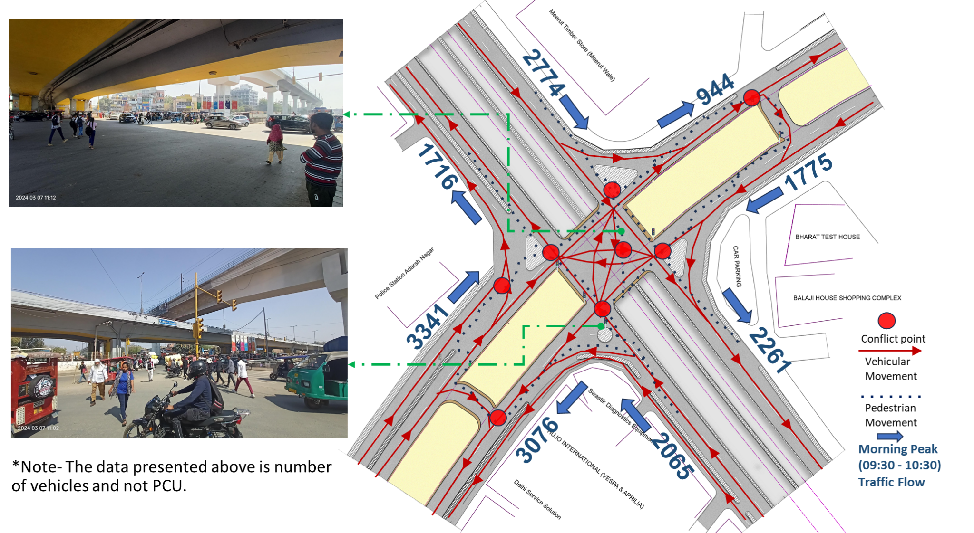

### : Existing scenario

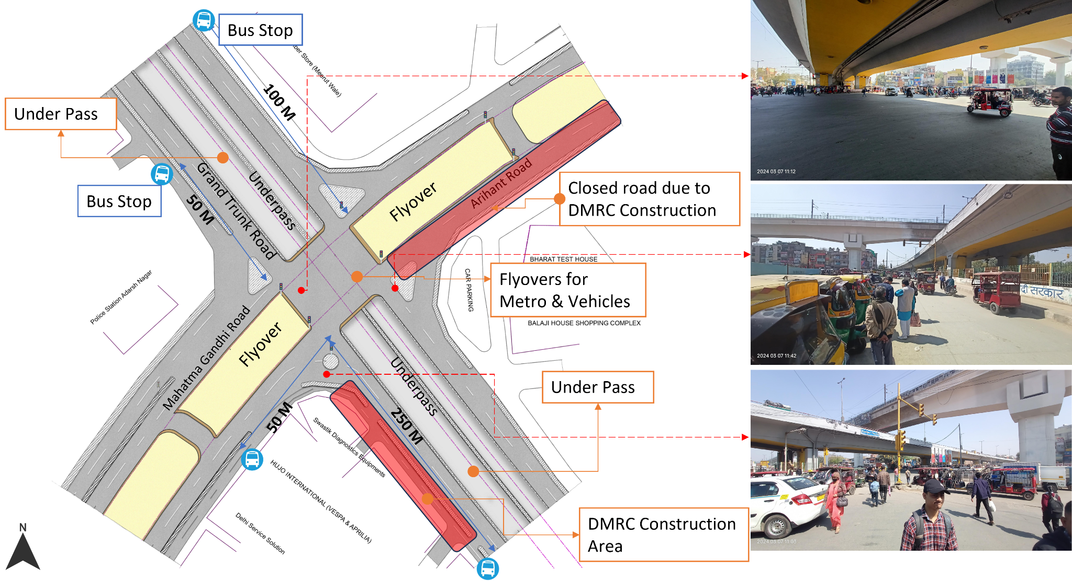

### : Issues identified

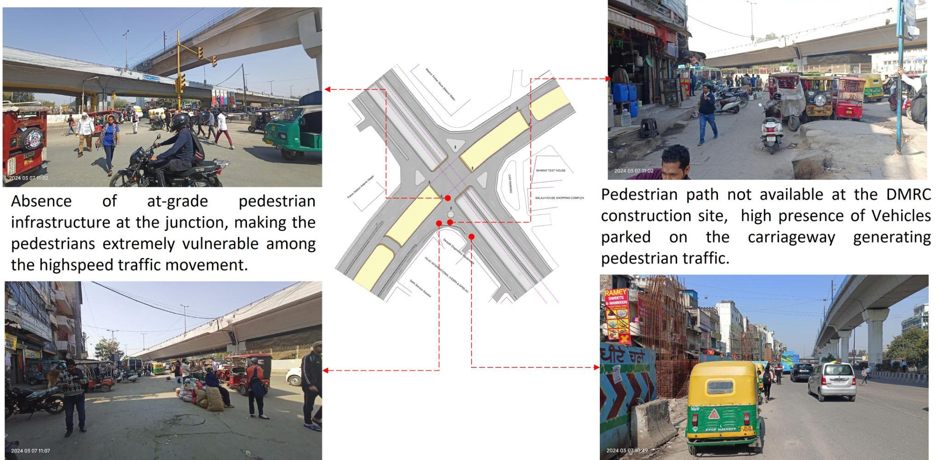

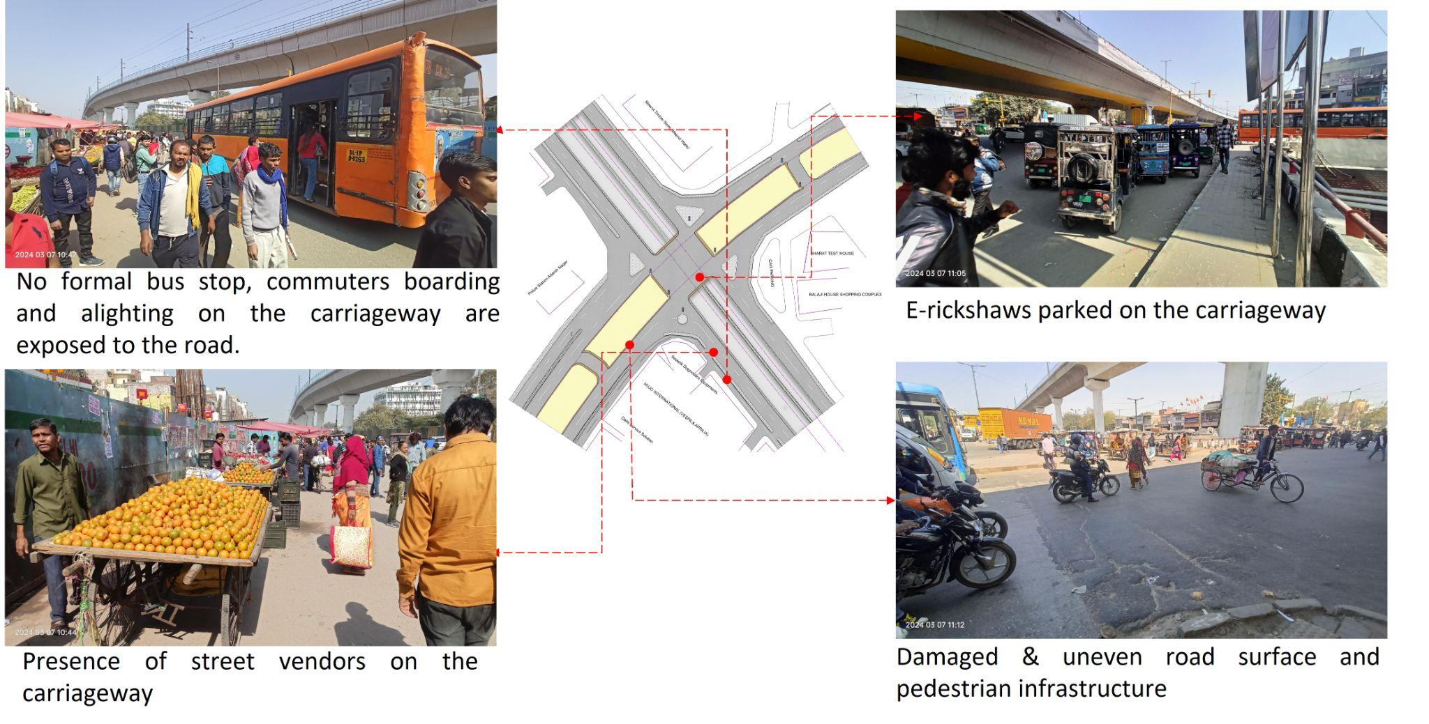

1.Absence of at-grade pedestrian infrastructure at the junction, making the pedestrians extremely vulnerable among the high speed traffic movement.

2.Lack of pedestrian paths at the Delhi Metro Rail Corporation (DMRC) construction, should be provided as per IRC SP 55.

3.Vehicles parked on the road are causing traffic congestion by obstructing the flow of traffic

4.Absence of bus stops at junctions due to construction by DMRC. DMRC should provide the temporary bus stops as per IRC 55.

5.Absence of safety measures on construction site.

6.Damaged & uneven road surface, raising the chances of accidents and injuries for vehicles and pedestrians.

7.Absence of kerb ramp and tactile flooring for differently abled users.

9.Absence of road markings, signages and speed control measures at the intersection.

10.Absence of delineators and reflectors on the median and carriageway edges.

11.Absence of chevron marking and hazard markers or flexible markers at bull noses.

12.Absence of segregated cycle tracks on arterial roads.

### : Proposed design

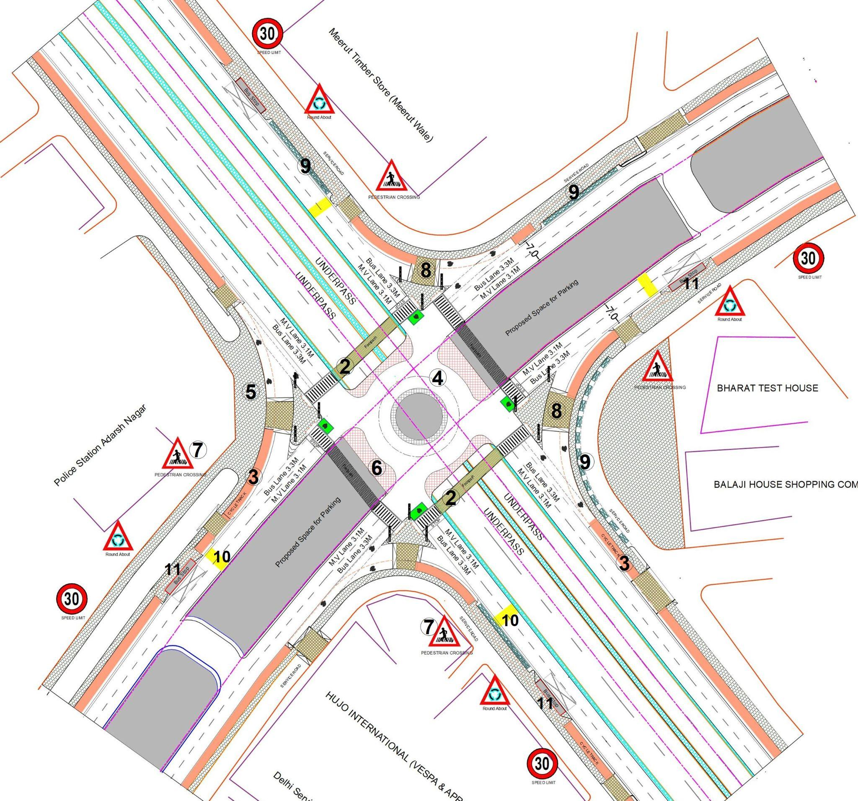

**Design Interventions:**

1. The junction is redesigned for the speed of 30 km/hr to ensure the safety of road users.
2. Proposed at-grade pedestrian crossing over vehicular underpass to increase the accessibility and safety for pedestrians.
3. Dedicated 2.5m wide cycle track to separate the motor traffic and the cyclists (as per Indian Road Congress (IRC): 11-2015).
4. Redesigned the geometry of the junction and proposed a roundabout to decrease the conflict area.
5. Provision of pedestrian infrastructure with tactile flooring as per IRC: 103-2022.
6. Provision of cobbled stone texture on surface to prevent speeding at junction.
7. Installation of signages - Speed Limit, stop sign, pedestrian crossing and other necessary signages.
8. Corrected turning radius, road width and proposed raised crossing on free left turn.
9. Provision of segregated e-rickshaw bays at junctions to reduce congestion.
10. Provision of rumble strips to slow down the through traffic(as per IRC code 99-2018, Pg 10).
11. Proposed new bus stops near the junction (30m-50m) on each approaching road to reduce the pedestrian crossing movement.
12. Demarcation of road markings (properly painted as per standards IRC:35-2015).

### : Summary budget estimates

| **S.No** | **Component** | **Details** | **Notes** | **Rate (per sq.m)** | **Cost (INR)** | **Cost (INR, crores)** |
| --- | --- | --- | --- | --- | --- | --- |
| **A** | **CIVIL WORK** |  |  |  |  |  |
| A.1 | Footpath (Primary, Secondary including other Flooring area) | 2m to 3m wide segregated footpath with tactile pavers | Providing and laying of footpath 2m to 3m wide, including earthwork and base layer - PCC, GSB and finishing material. | 3006 | 10,165,562 | 1.017 |
| A.2 | Raised Crossing | Raised crossing with 80mm thick pavers and DQ stone surface | Providing and laying Raised crossing with 80 mm thick pavers blocks, and DQ stone including Earth work and Base layers- PCC (M15), RCC (M30 Design mix) & GSB etc. | 3763 | 1,283,293 | 0.128 |
| A.3 | Cycle Infrastructure | 2.5m wide segregated cycle track | Providing and laying cycle track (2.5mt wide segregated) including Earth work and Base layers- PCC (M15), RCC (M40 Design mix) & GSB etc. also thermoplastic paint for marking and cycle symbol and spring post etc | 3711 | 4,687,588 | 0.469 |
| A.4 | CC Items (Kerbs, Pipe, etc) | Kerb stones, Bollards, Kerb Channels etc. | Providing and fixing Kerbs, Bollards, and Kerb Channel etc. in CC. |  | 1,657,171 | 0.166 |
| A.5 | Signages | Mandatory, Cautionary and Informatory Sign Boards of different sizes | Providing and fixing Signage Mandatory, Cautionary and informatory sign board including all the fixing and labours etc. |  | 96,731 | 0.010 |
| A.6 | Marking | Thermoplastic Paint Marking (Edge lines, Centre Line, Lane Marking, Hazard Marking, Chevron, Zebra Crossing, Bar Marking, etc) | Providing and applying road marking strips (retro- reflective) of specified shade/ colour using hot thermoplastic material for road marking. | 748 | 433,724 | 0.043 |
| A.7 | Special Zones | Provision of Sitting Bollards, CC Benches, GRC Jali, Pergola, Dustbin etc. | Miscellaneous items- Provision of Sitting Bollards, CC Benches, GRC Jali, Pergola, Dustbin etc. complete items- including foundation and fixing etc. |  | 143,470 | 0.014 |
| A.8 | Brick Work |  | Brick work with common burnt clay F.P.S. (non-modular) bricks of class designation 7.5 in foundation and plinth in: Cement mortar 1:4 (1 cement: 4 coarse sand) | 7370.65/CUM | 442,239 | 0.044 |
| A.9 | Steel Reinforcement for RCC work |  | Steel reinforcement (in per kg) for R.C.C. work including straightening, cutting, bending, placing in position and binding all complete up to plinth level. Thermo-Mechanically Treated bars of grade Fe-500D or more | 107.85/kg | 64,710 | 0.006 |
| A.10 | Pavement Surface Dressing | Pavement of Bitumen layer on existing road surface | Surface dressing on old surface with hot bitumen of grade VG - 10 | 175.10 / sq.m | 1,674,656 | 0.167 |
| A.11 | Safety Management Equipment (as per design requirement) | Provision of Delineator Post, Spring Post, Cat eye/studs etc. | Miscellaneous items for Safety Management Equipment ( as per design requirement) -Provision of Delineator Post, Spring Post, Cat eye/studs etc.- including foundation and fixing etc. |  | 160,776 | 0.016 |
| A.12 | Bus Shelter | 10.5mX2.5m Bus Shelter (Stainless Steel Structure) |  |  | 7,200,000 | 0.720 |
| A.13 | Pedestrian Bridge | 24.5mX3.5m Footbridge (Stainless Steel Structure) | Providing and Fixing Stainless steel Foot over bridge (24.5mx3.5m) including earthwork, foundation and base layer etc. |  | 8,000,000 | 0.800 |
|  | **SUBTOTAL CIVIL WORK (A)** |  |  |  | **36,009,920** | 3.601 |
| **B** | Drainage, Irrigation & Plumbing | (Drainage items based on design proposal) | Drainage, Irrigation & Plumbing work @ 20% of the cost of Civil work | 20% | **7,201,984** | 0.720 |
| **C** | Electrical Work | (Light poles, junction box, other electrical works proposed based on design proposal) | Electrical work @25% of the cost of Civil work | 25% | **9,002,480** | 0.900 |
| **D** | Horticulture Work | (Landscape items based on design proposal) | Horticulture work @ 15% of the cost of Civil work | 15% | **5,401,488** | 0.540 |
| **E** | Dismantling / Demolition | -- | Dismantling work @ 15% of the cost of Civil work | 15% | **5,401,488** | 0.540 |
| **F** | Work Zone Safety & Management | -- | Work zone Management @ 5% of the cost of Civil work | 5% | **1,800,496** | 0.180 |
| **PART 1** | **SUBTOTAL PART 1 (A+B+C+D+E+F)** |  |  |  | **64,817,855** | 6.482 |
| **G** | Design Services & Support | -- | Design Consultancy (Preparation of Drawings, BOQ support, Work Zone plan, Site Supervision, Community Engagement & Liaison, Change Management @ 2% - 8% of the cost of Civil work. | **2%** | **1,296,357** | 0.130 |
| **H** | Survey Cost | -- | Survey Cost (Total Station Survey, underground services, tree demarcation, girths, level differences, steps etc @ (80,000 per junction - 250m on each arm) | 80000 | **80,000** | 0.008 |
| **PART 2** | **SUBTOTAL PART 2 (PART 1 + G +H)** |  |  |  | **66,194,213** | 6.619 |
| **J** | Contingencies '2.5% | -- | Contingencies (@2.5%) |  | **1,654,855** | 0.165 |
| **I** | GST ('@18%) | -- | GST @18% |  | **12,212,832** | 1.221 |
| **FINAL** | **GRAND TOTAL (PART 2 + J + I)** |  |  |  | **80,061,900** | 8.006 |

Notes:

1. This is a preliminary estimate. Final costing to be evaluated & approved by road owning agency.
2. DSR 2023 has been followed for all rates. Market Rate and Costing from part PWD projects has been included for certain items.
3. Cost of Drainage, Irrigation, Plumbing has been calculated at 20% of the civil work cost.
4. Cost of Electrical Work can be calculated at 20% - 25 % of the civil work cost.
5. Cost of Horticulture has been calculated at 15% of the civil work cost.
6. Cost of Dismantling has been calculated at 15% of the civil work cost.
7. Cost of Work Zone Management has been calculated at 5% of the civil work cost.
8. Cost for Design Support can range from 2% - 8%, and can vary from site to site. This should include Technical Assistance on drawings, 3D supports, Site Supervision, Change management.
9. Bus Shelter has been calculated at 18 L per shelter; can be changed as per design specific cost.
10. In case of new items specific to design, please add relevant rows in detail budget estimation and include the same in the budget summary under relevant head.

## : Kingsway Camp

### : General description of the site

Kingsway Camp Chowk (Latitude: 28° 41 '55.75"N, Longitude: 77° 12' 16.77"E) is a four-arm signalised Junction. The Intersecting Roads are Mahatma Gandhi Road (Arterial Road) and Surjit Singh Road (Collector Road).

### : Existing land use

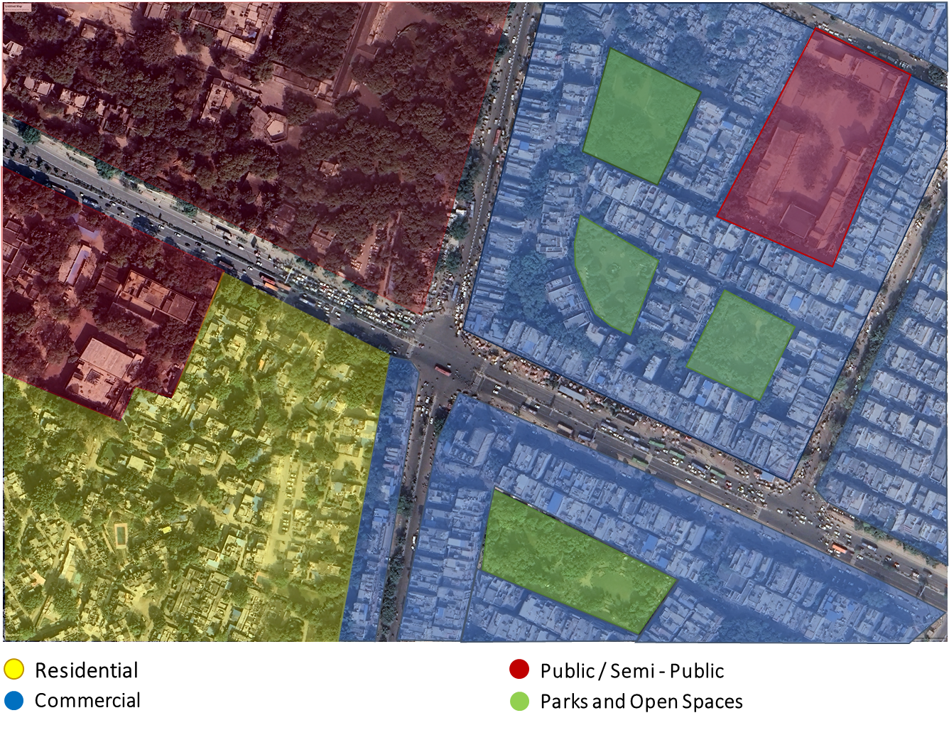

### : Existing conflict points

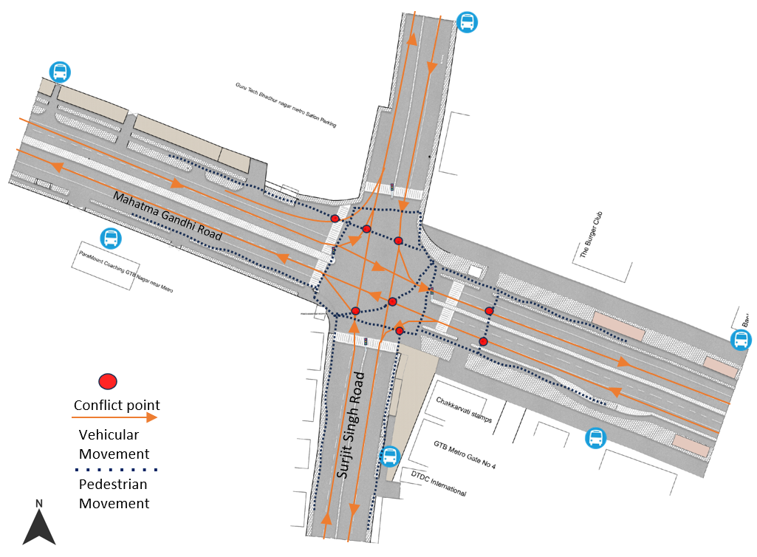

### : Existing scenario

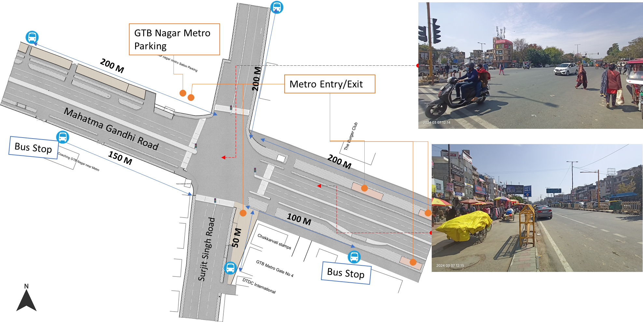

### : Issues identified

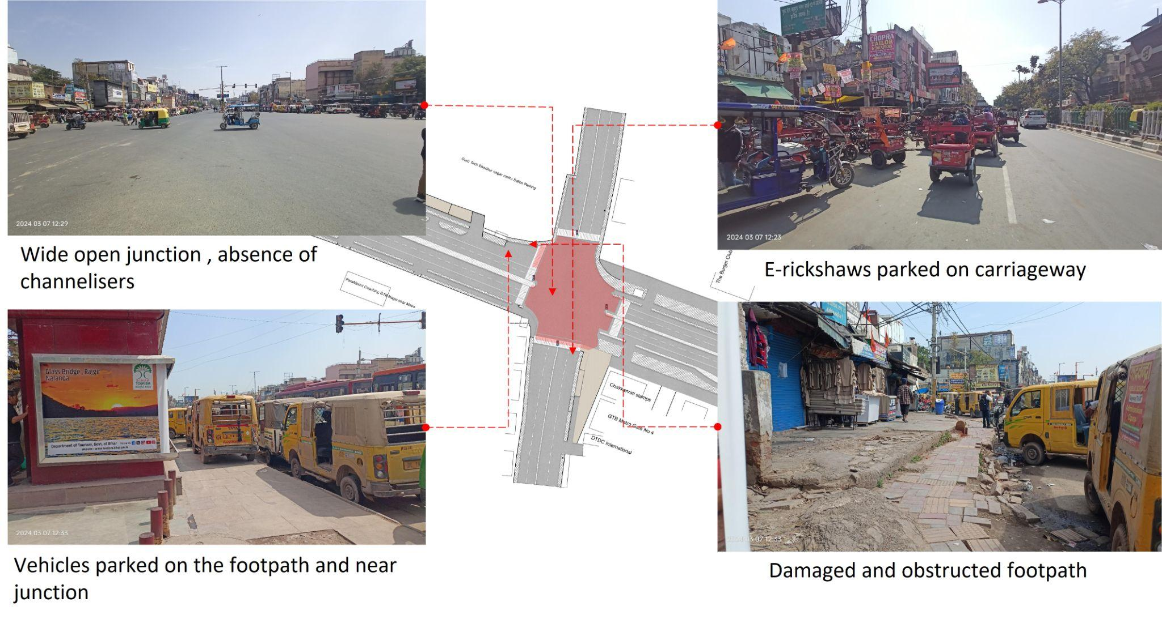

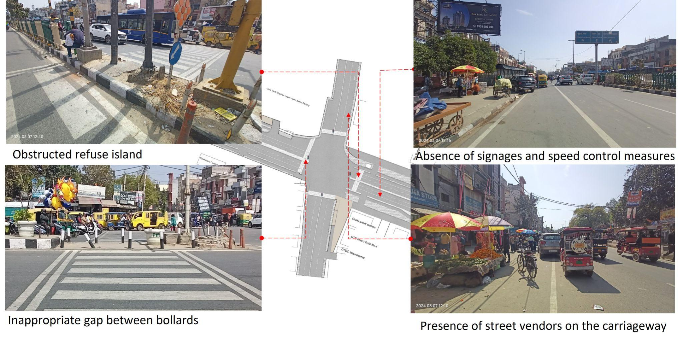

1.Unorganized parking of Gramin Sewa (shared taxi) and e-rickshaws near junctions.

2.Wide open resulting in conflicts, no channelizers.

3.Damaged and obstructed footpath, presence of street vendors and e-rickshaws.

4.Absence of kerb ramp and tactile flooring for differently abled users.

5.Absence of traffic calming near the junction.

6.Absence of signages and speed control measures at the intersection.

7.Absence of delineators and reflectors on the median and carriageway edges.

### : Proposed design

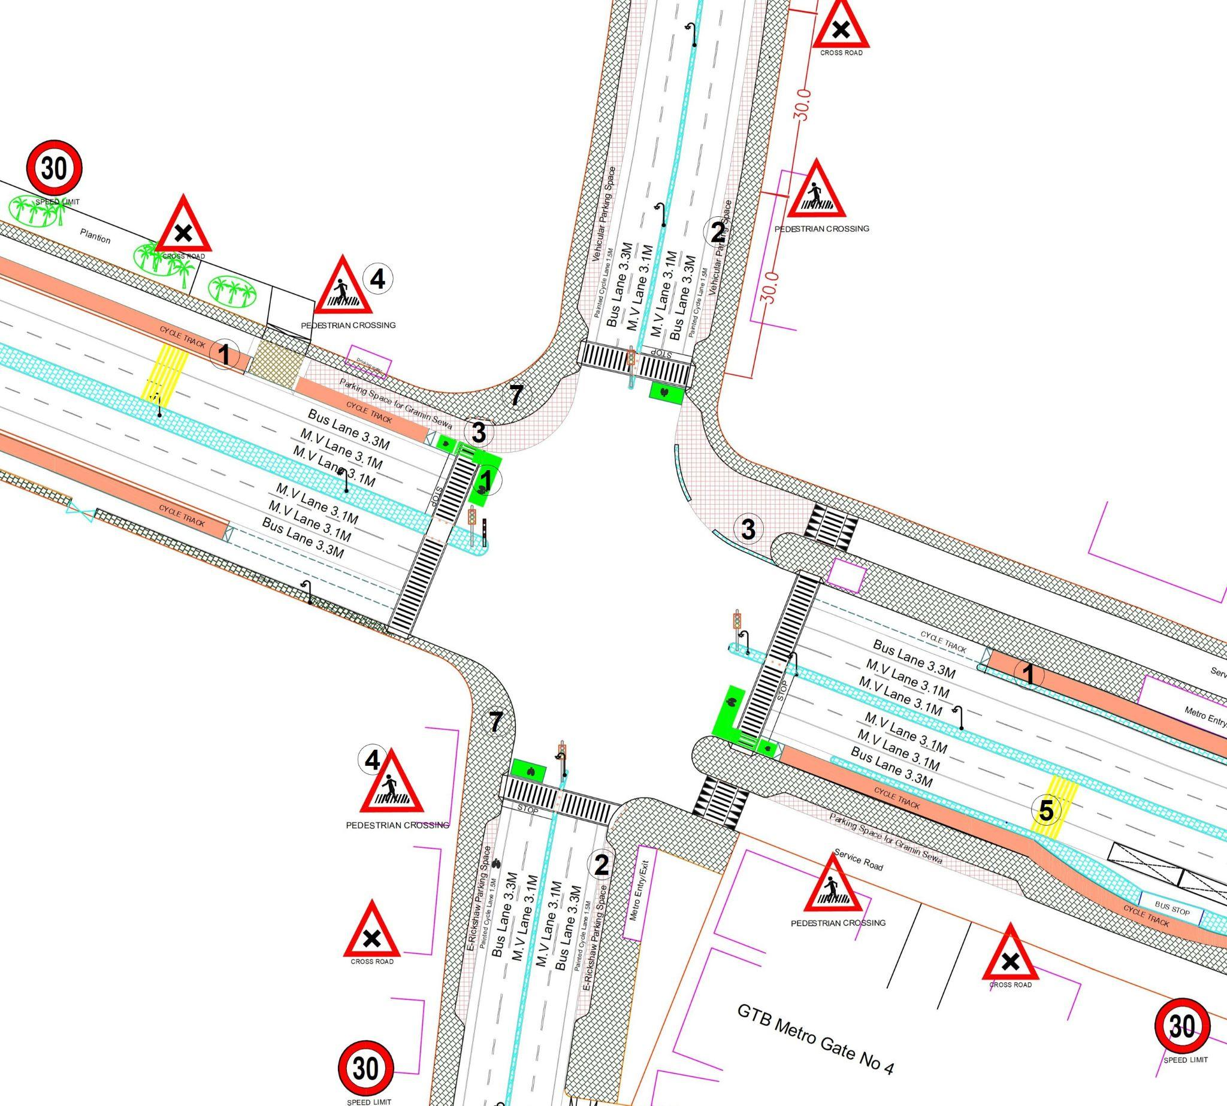

**Design Interventions:**

1. Dedicated 2.5m wide cycle track on arterial road and 1.8m painted cycle lane on collector road with cycle box marking to separate the motor traffic and the cyclists (as per IRC: 11-2015)
2. Provision of dedicated parking space for e-rickshaws, and vehicles
3. Provision of segregated gramin sewa parking space with cobbled stone texture to reduced conflict area at junction
4. Installation of signages - Speed Limit, stop sign, pedestrian crossing and other necessary Signages.
5. Provision of rumble strip to slow down the through traffic (as per IRC code 99-2018, Pg. 10)
6. Demarcation of road markings (properly painted as per standards IRC:35-2015).
7. Provision of pedestrian infrastructure with tactile flooring as per IRC: 103-2022.

### : Summary budget estimates

| **S.No** | **Component** | **Details** | **Notes** | **Rate (per sq.m)** | **Cost (INR)** | **Cost (INR, crores)** |
| --- | --- | --- | --- | --- | --- | --- |
| **A** | **CIVIL WORK** |  |  |  |  |  |
| A.1 | Footpath (Primary, Secondary including other Flooring area) | 2m to 3m wide segregated footpath with tactile pavers | Providing and laying of footpath 2m to 3m wide, including earthwork and base layer - PCC, GSB and finishing material. | 2365 | 9,225,842 | 0.923 |
| A.2 | Raised Crossing | Raised crossing with 80mm thick pavers and DQ stone surface | Providing and laying Raised crossing with 80 mm thick pavers blocks, and DQ stone including Earth work and Base layers- PCC (M15), RCC (M30 Design mix) & GSB etc. | 3816 | 553,310 | 0.055 |
| A.3 | Cycle Infrastructure | 2.5m wide segregated cycle track | Providing and laying cycle track (2.5mt wide segregated) including Earth work and Base layers- PCC (M15), RCC (M40 Design mix) & GSB etc. also thermoplastic paint for marking and cycle symbol and spring post etc | 5223 | 4,194,393 | 0.419 |
| A.4 | CC Items (Kerbs, Pipe, etc) | Kerb stones, Bollards, Kerb Channels etc. | Providing and fixing Kerbs, Bollards, and Kerb Channel etc. in CC. |  | 1,169,334 | 0.117 |
| A.5 | Signages | Mandatory, Cautionary and Informatory Sign Boards of different sizes | Providing and fixing Signage Mandatory, Cautionary and informatory sign board including all the fixing and labours etc. |  | 96,731 | 0.010 |
| A.6 | Marking | Thermoplastic Paint Marking (Edge lines, Centre Line, Lane Marking, Hazard Marking, Chevron, Zebra Crossing, Bar Marking, etc) | Providing and applying road marking strips (retro- reflective) of specified shade/ colour using hot thermoplastic material for road marking. | 748 | 574,310 | 0.057 |
| A.7 | Special Zones | Provision of Sitting Bollards, CC Benches, GRC Jali, Pergola, Dustbin etc. | Miscellaneous items- Provision of Sitting Bollards, CC Benches, GRC Jali, Pergola, Dustbin etc. complete items- including foundation and fixing etc. |  | 143,470 | 0.014 |
| A.8 | Brick Work |  | Brick work with common burnt clay F.P.S. (non-modular) bricks of class designation 7.5 in foundation and plinth in: Cement mortar 1:4 (1 cement: 4 coarse sand) | 7370.65/CUM | 294,826 | 0.029 |
| A.9 | Steel Reinforcement for RCC work |  | Steel reinforcement (in per kg) for R.C.C. work including straightening, cutting, bending, placing in position and binding all complete up to plinth level. Thermo-Mechanically Treated bars of grade Fe-500D or more | 107.85/kg | 43,140 | 0.004 |
| A.10 | Pavement Surface Dressing | Pavement of Bitumen layer on existing road surface | Surface dressing on old surface with hot bitumen of grade VG - 10 | 175.10 / sq.m | 227,630 | 0.023 |
| A.11 | Safety Management Equipment (as per design requirement) | Provision of Delineator Post, Spring Post, Cat eye/studs etc. | Miscellaneous items for Safety Management Equipment (as per design requirement) -Provision of Delineator Post, Spring Post, Cat eye/studs etc.- including foundation and fixing etc. |  | 97,961 | 0.010 |
|  | **SUBTOTAL CIVIL WORK (A)** |  |  |  | **16,620,948** | 1.662 |
| **B** | Drainage, Irrigation & Plumbing | (Drainage items based on design proposal) | Drainage, Irrigation & Plumbing work @ 20% of the cost of Civil work | 20% | **3,324,190** | 0.332 |
| **C** | Electrical Work | (Light poles, junction box, other electrical works proposed based on design proposal) | Electrical work @25% of the cost of Civil work | 25% | **4,155,237** | 0.416 |
| **D** | Horticulture Work | (Landscape items based on design proposal) | Horticulture work @ 15% of the cost of Civil work | 15% | **2,493,142** | 0.249 |
| **E** | Dismantling / Demolition | -- | Dismantling work @ 15% of the cost of Civil work | 15% | **2,493,142** | 0.249 |
| **F** | Work Zone Safety & Management | -- | Work zone Management @ 5% of the cost of Civil work | 5% | **831,047** | 0.083 |
| **PART 1** | **SUBTOTAL PART 1 (A+B+C+D+E+F)** |  |  |  | **29,917,707** | 2.992 |
| **G** | Design Services & Support | -- | Design Consultancy (Preparation of Drawings, BOQ support, Work Zone plan, Site Supervision, Community Engagement & Liaison, Change Management @ 2% - 8% of the cost of Civil work. | **2%** | **598,354** | 0.060 |
| **H** | Survey Cost | -- | Survey Cost (Total Station Survey, underground services, tree demarcation, girths, level differences, steps etc @ (80,000 per junction - 250m on each arm) | 80000 | **80,000** | 0.008 |
| **PART 2** | **SUBTOTAL PART 2 (PART 1 + G +H)** |  |  |  | **30,596,061** | 3.060 |
| **J** | Contingencies '2.5% | -- | Contingencies (@2.5%) |  | **764,902** | 0.076 |
| **I** | GST ('@18%) | -- | GST @18% |  | **5,644,973** | 0.564 |
| **FINAL** | **GRAND TOTAL (PART 2 + J + I)** |  |  |  | **37,005,936** | 3.701 |

**Notes:**

1. This is a preliminary estimate. Final costing to be evaluated & approved by road owning agency.
2. DSR 2023 has been followed for all rates. Market Rate and Costing from part PWD projects has been included for certain items.
3. Cost of Drainage, Irrigation, Plumbing has been calculated at 20% of the civil work cost.
4. Cost of Electrical Work can be calculated at 20% - 25 % of the civil work cost.
5. Cost of Horticulture has been calculated at 15% of the civil work cost.
6. Cost of Dismantling has been calculated at 15% of the civil work cost.
7. Cost of Work Zone Management has been calculated at 5% of the civil work cost.
8. Cost for Design Support can range from 2% - 8%, and can vary from site to site. This should include Technical Assistance on drawings, 3D supports, Site Supervision, Change management.
9. Bus Shelter has been calculated at 18 L per shelter; can be changed as per design specific cost.
10. In case of new items specific to design, please add relevant rows in detail budget estimation and include the same in the budget summary under relevant head.

## : Safe School Zone: Sachdeva Public School, Rohini

### : General description of the site

Situated at Dr. KN Katju Marg (44 m ROW connecting H.L Parwana Road (23 m ROW) ) and adjacent to an MCD road ( 7m ROW), with , the Sachdeva Public School (SPS) Rohini (120m x 135m block) is the pilot school zone site in the North district (28°43'30.1"N 77°07'42.6"E) With the observed issues of over speeding and lack of traffic calming devices, the site was identified as a potential crash location as per the ‘Data to Action report 2022-23’. The school is located in Rohini, with land use prominently residential in nature. Within its proximity, there is a gas station, Tata electrical plant, and an ESIC hospital. The school has a total of five gates. Currently, only 3 gates are used during the entry and exit hours.

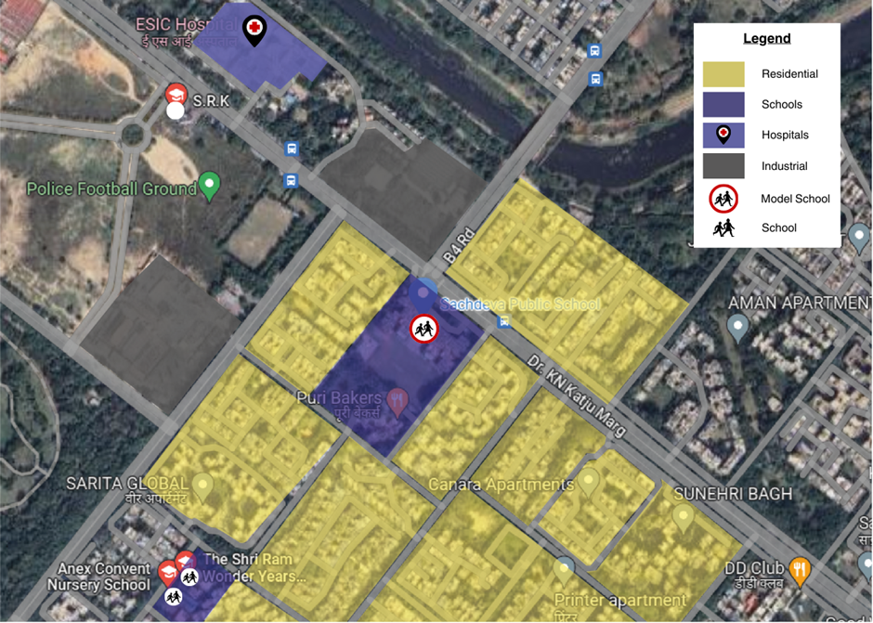

### : Existing scenario

SPS Rohini is a co-ed school from class Nursery to XII (age 5 to 17 yrs), with a total enrollment of 3500+ students as per the academic year 2022-2023. The larger mode of transport observed are vans, private vehicles and walking. Others include cab, Three wheeled Scooter Rickshaw (TSR), cycle etc. The graph below shows the data collected online via road safety clubs.

Figure 16: Home to School travel modal distribution: SPS Rohini

Figure 17: School to home travel modal distribution

Source: HumanQind School Travel Survey 22-23)

* Most of the students that responded come to school either by private vehicles, vans or by walking. Public transport and cycling are amongst the least used modes.
* Between morning (home to school) and afternoon (school to home) trips, there are very few changes that we see in modal share. One of the major changes is the decrease in usage of private vehicles and vans in the afternoon; the increase can be seen in use of public transport.

### : Issues identified

**Observations on Road Infrastructure:** Due to the traditional vehicle-centric planning approach, the road infrastructure does not promote pedestrian safety and creates an unsafe environment for the vulnerable road users, putting school children at risk. The school is located on an arterial road which is mostly non signalised. Instances of high speeds have been observed. Lack of continuous footpaths, encroachments, no space to cycle safely, traffic calming, signages and marking, and non-functional traffic lights, high conflict of moving vehicles with students is visible. Students walk and cycle between parked vehicles on the carriageway and service lane. The zone lacks pedestrian amenities such as waiting areas & integrated vendor spaces. No drop off and pick-up areas have been assigned. Better lighting and drainage are needed. There is a high foliage of wide trees that occupy ~1m or more space.

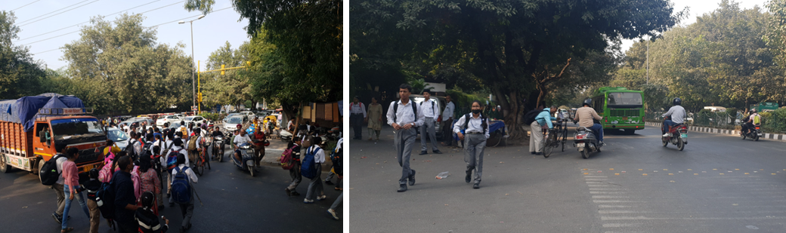

**Type and quality of enforcement:** Unorganised parking, lack of dedicated pick up and drop off zone and traffic management in the school vicinity leads to an uncontrolled environment and circumstances. The school is located at a T intersection which has pedestrian access but cars do not slow down. Overspeeding is observed to be a common phenomenon resulting in difficulties for children to cross the road.

**Road users’ behaviour and mobility patterns:** To understand the patterns of movements and conflicts in the school zone, activity mapping was conducted in morning hours (home to school traffic) and exit timing during afternoon (school to home).

### : Activity map

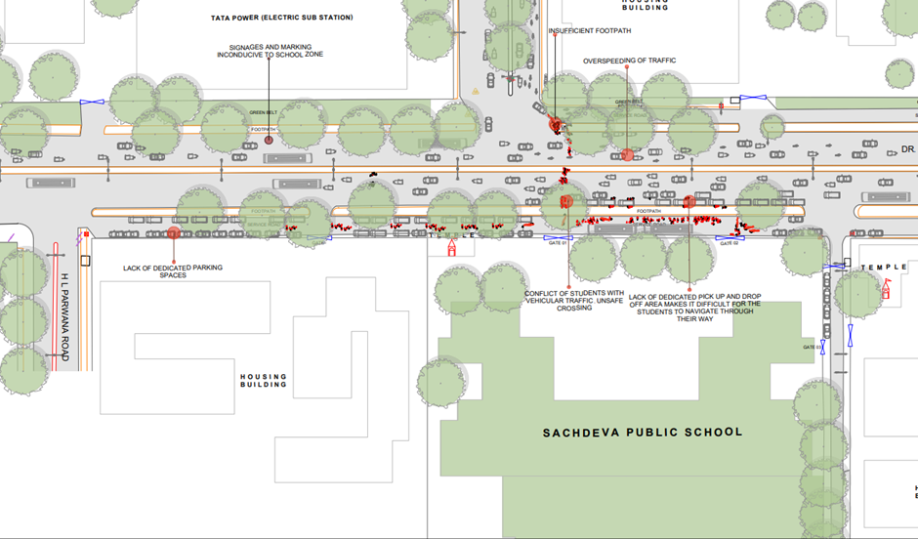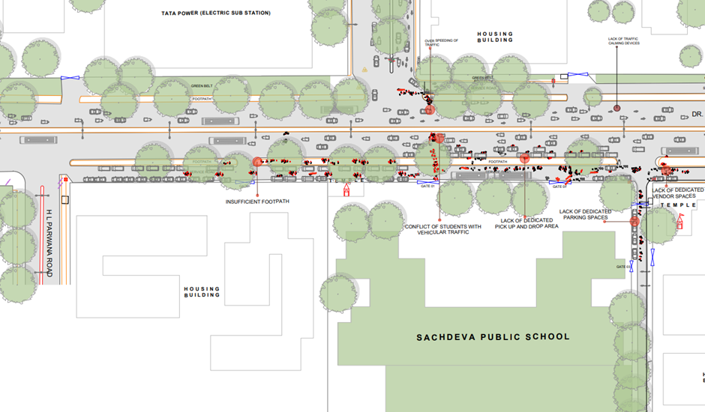

Activity Mapping: Home to School (Above), Activity Mapping School to Home (Below)

**Key Findings:**

|  |  |
| --- | --- |
| **Morning: Home to School**   * Buses and vans use separate sections of service lanes to offload students near gates. Due to inadequate planning and improper parking, students find it difficult to navigate their way to the school gate. * Private vehicles occupy footpaths and service lanes making it inaccessible to the students and parents who walk to school. Pedestrians and children as young as 5 yrs walk on the carriageway along with high-speed traffic. Teachers mainly park in the minor road towards the market. * Parents pick and drop off students on both sides of the main arterial road due to which students risk unsafe crossings. Parents and caregivers are observed standing due to lack of waiting spaces near the school gate. * High speed and high conflict of motorised and non-motorised vehicles is observed between school traffic and through traffic. | **Afternoon: School to Home**   * The conflict points relatively increase with the increase in general traffic on the road. * The vans and e-rickshaw due to no pick-up points are scattered on the carriageway. Students find it difficult to navigate through them. Students have also mentioned that they tend to get late because of overcrowding and congestion at the school gate. * The traffic lights near the school vicinity are non-functional with no traffic calming devices or pedestrian crossing due to which students find it difficult to cross the road. |

**Fear experienced during school travel:** Based on data from the school, Half of the students feel unsafe during their travel to school. Vans were reported to be where the students feel the most unsafe with more than 90% of them reporting they feel unsafe while travelling in vans. The travel modes in which the students feel the safest are - auto rickshaws (TSR), private vehicles, cabs, walking and public transport (< 30%). Students travelling by school bus and cycles also feel unsafe while travelling. There is a very little change in this behaviour between morning and afternoon trips. (Source: HumanQind Safe School Survey 22-23)

**Infrastructure Interventions to be taken up:** While 20% of students responded that no change was required in their travel, 66% students wanted no crowding outside the school. Among total, 63%, 58% and 57% respondents wanted traffic lights and safe crossing, organised entry and exit of students and footpath for walking & comfortable waiting spaces, respectively. Also, 55% of respondents opted for a vehicle free street. (Source: HumanQind Safe School Zone Survey 22-23)

**Infrastructure Interventions and Academic Performance:** Academic performance is not a result of a child's ability and focus alone; rather it is a combination of various factors, of which travel to school is an important one. Noise, long hours of travel and lack of transport can impact the energy levels and the stress experienced by the students. This in turn, can impact their learning experience and performance.

On the question of infrastructural changes, 52% of the students wanted to improve their last mile walking experience to improve upon academics; 45% voted for less travel time, 41% opted for availability of public transport near school and 40% also responded to less walking time that helps them perform better in academics.(Source: HumanQind Safe School Zone Survey 22-23).

### : Proposed design

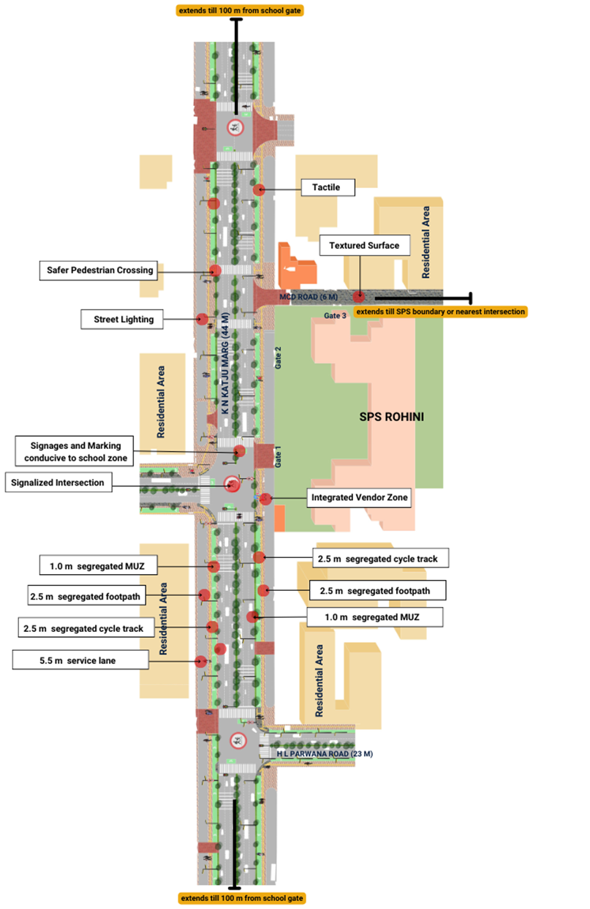

**Design Interventions:**

The proposal prepared by road safety clubs (Refer Safer Delhi through Road Safety Clubs) is called ‘Sensitive Abode of Learning’ aligning to pedestrian first approach, traffic safety principles, UN Sustainable Development Goals and Ladder of Children Participation. Sensitive Abode of Learning is an area plan connecting 4 schools and the neighbourhood to 950 m of school zone development. The entire plan is in adherence to Indian Road Congress Guidelines. To reduce speeds and conflicts, the school zone has been designed as per 20 km/h or lower speed, promoting walkability, and safe mobility. Continuous footpaths with designated boarding areas and drop off zones have been proposed. With a mix of arterial, collector streets and local streets, each of the ROW are designed as per their street typology. The access function in arterial streets has been proposed via service lanes.

* 2.5m segregated footpaths on both sides.
* 2.5m segregated cycle track on both sides.
* 1.0 m of Multi-Utility Zone for Services such as lighting and drainage.
* Designated boarding areas and drop off zones near school gates.
* Waiting spaces and street furniture integrated.
* School specific signage and marking.
* Wide Pedestrian Crossings to accommodate school traffic.
* Major intersections have been rationalised. The intersection in front of Gate 1 has been proposed to be signalised and allow turning traffic. With Gate 1, this intersection will function as an arm intersection, allowing smooth movement of school traffic in both directions.
* Table top crossings and texture change on surface has been proposed for minor intersections towards the MCD Road.
* Continuous carriageway (3 lanes each direction on K N Katju Marg) and (two lane each direction on H L Parwana Road and Shahid Captain Dahiya Marg).

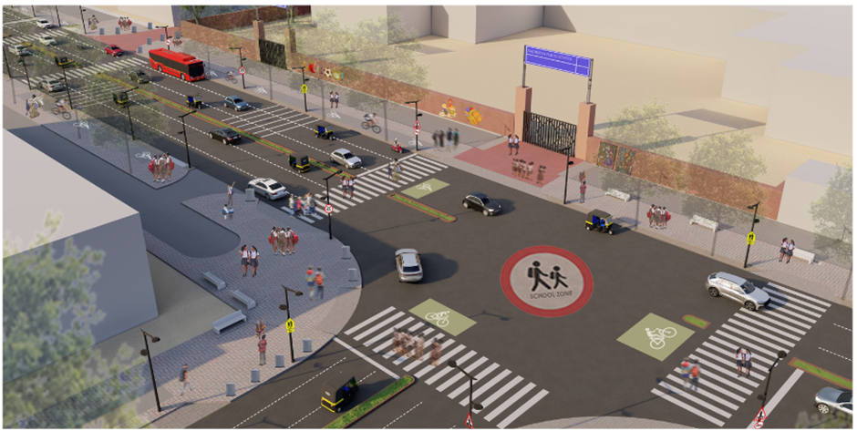

Proposed Render of K N Katju Marg in front of Sachdeva Public School

### : Summary budget estimates

| **S.No** | **Component** | **Details** | **Notes** | **Rate (per sq.m)** | **Cost (INR)** | **Cost (INR, crores)** |
| --- | --- | --- | --- | --- | --- | --- |
| **A** | **CIVIL WORK** |  |  |  |  |  |
| A.1 | Footpath (Primary, Secondary including other Flooring area) | 2.5m segregated footpath with tactile pavers in both directions | Providing and laying of footpath 2m to 3m wide, including earthwork and base layer - PCC, GSB and finishing material. | 2838 | 11808105 | 1.181 |
| A.2 | Raised Crossing | Signalised Intersections and traffic calming at entry/exits | Providing and laying Raised crossing with 80 mm thick pavers blocks, and DQ stone including Earth work and Base layers- PCC (M15), RCC (M30 Design mix) & GSB etc. | 6584 | 7242078 | 0.724 |
| A.3 | Cycle Infrastructure | 2.5m segregated cycle tracks on both sides | Providing and laying cycle track (2.5mt wide segregated) including Earth work and Base layers- PCC (M15), RCC (M40 Design mix) & GSB etc. also thermoplastic paint for marking and cycle symbol and spring post etc | 3948 | 4145111 | 0.415 |
| A.4 | CC Items (Kerbs, Pipe, etc) | Provision of bollards, kerbs - mountable, kerb channels, etc | Providing and fixing Kerbs, Bollards, and Kerb Channel etc. in CC. |  | 2652904 | 0.265 |
| A.5 | Signages | Provision of signages as per IRC 67 for school zone & 20 km/h | Providing and fixing Signage Mandatory, Cautionary and informatory sign board including all the fixing and labours etc. |  | 623973 | 0.062 |
| A.6 | Marking | Provision of signages as per IRC 35 for school zone & 20 km/h | Providing and applying road marking strips (retro- reflective) of specified shade/ colour using hot thermoplastic material for road marking. | 863 | 1686803 | 0.169 |
| A.7 | Special Zones | Provision of seating areas, vendor spaces and play integrated with design proposal | Miscellaneous items- Provision of Sitting Bollards, CC Benches, GRC Jali, Pergola, Dustbin etc. complete items- including foundation and fixing etc. |  | 419697 | 0.042 |
| A.8 | Brick Work | -- | Brick work with common burnt clay F.P.S. (non-modular) bricks of class designation 7.5 in foundation and plinth in: Cement mortar 1:4 (1 cement: 4 coarse sand) | 7370.65/CUM | 208295 | 0.021 |
| A.9 | Steel Reinforcement for RCC work | -- | Steel reinforcement (in per kg) for R.C.C. work including straightening, cutting, bending, placing in position and binding all complete up to plinth level. Thermo-Mechanically Treated bars of grade Fe-500D or more | 107.85/kg | 930746 | 0.093 |
| A.10 | Pavement Surface Dressing | Pavement of Bitumen layer on existing road surface | Surface dressing on old surface with hot bitumen of grade VG - 10 | 175.10 / sq.m | 0 | 0.000 |
| A.11 | Safety Management Equipment (as per design requirement) | Provision of Delineator Post, Spring Post, Cat eye/studs etc. | Miscellaneous items for Safety Management Equipment (as per design requirement) -Provision of Delineator Post, Spring Post, Cat eye/studs etc.- including foundation and fixing etc. |  | 10500 | 0.001 |
| A.12 | Bus Shelter | Provision of new bus shelter. |  |  | 1800000 |  |
|  | **SUBTOTAL CIVIL WORK (A)** |  |  |  | **31528211** | 3.153 |
| **B** | Drainage, Irrigation & Plumbing | Details promote a catch pit along the footpath linked to existing manholes. Bell mouths are not recommended. Details to be finalised with PWD | Drainage, Irrigation & Plumbing work @ 20% of the cost of Civil work | 20% | **6305642** | 0.631 |
| **C** | Electrical Work | 5m and 10m light poles have been located alongside the footpath / MUZ. Details to be finalised with PWD. | Electrical work @25% of the cost of Civil work | 25% | **7882053** | 0.788 |
| **D** | Horticulture Work | To increase green cover and shade, landscape plans promote ground cover and trees for seasonal variation and colour. Irrigation plan to be finalised with PWD. | Horticulture work @ 15% of the cost of Civil work | 15% | **4729232** | 0.473 |
| **E** | Dismantling / Demolition | -- | Dismantling work @ 15% of the cost of Civil work | 15% | **4729232** | 0.473 |
| **F** | Work Zone Safety & Management | -- | Work zone Management @ 5% of the cost of Civil work | 5% | **1576411** | 0.158 |
| **PART 1** | **SUBTOTAL PART 1 (A+B+C+D+E+F)** |  |  |  | **56750779** | 5.675 |
| **G** | Design Services & Support | -- | Design Consultancy (Preparation of Drawings, BOQ support, Work Zone plan, Site Supervision, Community Engagement & Liaison, Change Management @ 2% - 8% of the cost of Civil work. | **5%** | **2837539** | 0.284 |
| **H** | Survey Cost | -- | Survey Cost (Total Station Survey, underground services, tree demarcation, girths, level differences, steps etc @ (80,000 per junction - 250m on each arm) | 80000 | **80000** | 0.008 |
| **PART 2** | **SUBTOTAL PART 2 (PART 1 + G +H)** |  |  |  | **59668318** | 5.967 |
| **J** | Contingencies '2.5% | -- | Contingencies (@2.5%) |  | **1491708** | 0.149 |
| **I** | GST ('@18%) | -- | GST @18% |  | **11008805** | 1.101 |
| **FINAL** | **GRAND TOTAL(INR) (PART 2 + J + I)** |  |  |  | **72168831** | **7.217** |

Notes:

1. DSR 2023 has been followed for all rates. Market Rate and Costing from part PWD projects has been included for certain items. This is a preliminary estimate. Final costing to be evaluated & approved by road owning agency
2. Cost of Drainage, Irrigation, Plumbing has been calculated at 20% of the civil work cost
3. Cost of Electrical Work can be calculated at 20% - 25 % of the civil work cost
4. Cost of Horticulture has been calculated at 15% of the civil work cost
5. Cost of Dismantling has been calculated at 15% of the civil work cost
6. Cost of Work Zone Management has been calculated at 5% of the civil work cost
7. Cost for Design Support can range from 2% - 8%, and can vary from site to site. This should include Technical Assistance on drawings, 3D supports, Site Supervision, Change management
8. Bus Shelter has been calculated at 18 L per shelter; can be changed as per design specific cost
9. In case of new items specific to design, please add relevant rows in detail budget estimation and include the same in the budget summary under relevant head

**Link to the appendix report:** [**https://tripc.iitd.ac.in/publication/report**](https://tripc.iitd.ac.in/publication/report)

